Project Report
Catering Services Database

Team Coordinator Name: Naga Moulika Vema
Team Members Names - Group 12
  - Naga Moulika Vema
  - Moulya Reddygari Bhupal
  - Venkata Naga Triveni Bottu
  - Tejaswi Gummadi
  - Sushmitha Gangadari

Catering Services Database

Objective
Catering Services is an event management company within the university, specializing in the food supply chain and organizing various events. To efficiently manage its operations, a comprehensive database is required to track and store information related to events, employees, managers, schedules, and inventory. The current focus of this project is on managing events and scheduling employees for these events.
Catering Services manages diverse university events, including daily food supplies to cafés, meetings, gatherings, and sports events, making it impractical to manage all this data through Excel spreadsheets.
The purpose of the database is to provide a user-friendly system that offers clear visibility into employee assignments, event locations, and schedules. The database captures key details such as employee roles (managers, supervisors, full-time, part-time) and allows supervisors to organize events, determine staffing needs, and manage food supplies. Additionally, managers use the system to manage payroll and distribute coupons based on employees' working hours.

Scope
The database will store critical information about the company’s operations, including proprietary data related to events, employee management, food inventory, and payroll.
- It will serve as the central hub for organizing and managing:
  - Employee information (including classifications such as part-time, full-time, supervisors, and non-supervisors)
  - Event scheduling and employee assignments to events
  - Food supply management and menu planning
  - Payroll and coupon distribution for employees based on their hours worked.
- The database will ensure that all events held across various university locations are efficiently tracked and managed.

Key Functionalities
- Employee Management: Storing detailed employee information, including roles and classifications.
- Event Coordination: Planning and tracking events, including the location, and required staff.
- Menu and Food Inventory Management: Organizing food supply for events and daily café deliveries.
- Event-Employee Mapping: Assigning employees to events based on requirements and availability.
- Location Tracking: Managing events across different university venues.
The database is designed as an enterprise-level system, supporting the entire company's operational needs and facilitating the smooth coordination of various tasks across departments.

User Requirements
- The system must notify managers first about any new events. Based on the event type, the manager must be able to assign supervisors to oversee the event.
- The system must allow managers to select and allocate event locations based on the event’s type and specific requirements.
- The system should enable supervisors to assign specific tasks or duties to employees working at the event.
- Supervisors must be able to select employees for specific events through the system.
- The system must enable managers to allocate work shift-related coupons to employees.
- The system should support managers in processing payments for employees according to the work they have completed at events.
- Historical tracking and reporting for analysis of events and employee performance.
- Multi-user access (Managers and Supervisors) to ensure concurrent use.
- Table/field-level security for sensitive data.
- Role-based permissions for data entry and task management.
- Scalability for future growth in operations.
- Data backup and recovery for data protection.
These user requirements outline the various tasks that the system should enable its users (managers and supervisors) to perform. These include event management, task assignment, employee selection, coupon distribution, and payroll processing. These requirements will also ensure the system effectively supports the operational needs of Catering Services, enhancing efficiency, security, and scalability.

Business Rules
    - Manager Assignment to Events
  - Only managers have authorization to create or drop events in the system.
  - This Ensures that the responsibility of event management is assigned only to authorized personnel.
2. Supervisors Can Only Be Assigned by Managers
  - Supervisors for an event must be assigned by a manager and cannot self-assign.
  - Maintains managerial control over event coordination and staffing decisions.
3. Employee Availability Verification
  - Employees can only be assigned to an event if they are available and not already scheduled for another event at the same time.
  - Prevents scheduling conflicts and ensures proper employee allocation.
4. Full-time Employees Must Be Assigned to Priority Events
- Full-time employees must be prioritized for assignment to major events, while part-time employees are assigned to smaller or secondary events.
- Ensures that key events are staffed with full-time personnel who are likely more experienced.
5. Coupon Distribution Based on Hours Worked
- Part Time Employees will receive coupons based on the total number of hours worked during an event.
- Standardizes the reward system based on actual participation and contribution.
6. Event Location Assignment Restrictions
- An event can only be assigned to a location that is marked as available in the system.
- Prevents double-booking and ensures that the venue is available for the event.
7. Supervisors Can Only Manage Employees for Assigned Events
- Supervisors can only assign work to employees for events they have been assigned to manage.
- Restricts supervisors to managing only their designated events, keeping clear oversight.

8. Daily Event Limit Per Location
- No more than three events can be scheduled at the same location on a single day.
- Avoids overuse of a venue and ensures that the location can accommodate all planned events.
9. Employee Classification and Work Type
- Full-time and part-time employees must be differentiated in the system, and tasks assigned based on their job classification.
- Ensures clarity and proper workload distribution according to employment status.

10. Salary Generation Based on Approved Events
- Employee salaries are generated only after event completion and approval from both supervisors and managers.
- Ensures exact salary calculations based on verified work hours.
11. Event Update Restrictions
- Only managers can update event details (location, time, or type) once the event is confirmed.
- Keeps event information correct and prevents unauthorized changes.
12. Inventory Updates Must Precede Event Start
- Food inventory must be updated and confirmed at least 24 hours before the event starts.
- Ensures that food supplies are prepared and delivered on time for the event.
These business rules set up the necessary controls for smooth operations within the system, ensuring that events are managed efficiently, employees are properly scheduled, and inventory is tracked accurately.

Entities

  - Employee:
employeeID,
emaiID,
name {firstName, middleName,lastName},
phoneNum,
address {aptNum, streetname, pincode},
gender,
employmentType,
roleID.

  - Role:
roleID,
roleName,
canAssignEvents,
canDistributeCoupons,
canViewSalaries,
canManageInventory,
canScheduleEvents.

  - Events:
eventID,
eventName,
locationID,
eventTime,
eventHours,
handledByManagerID,
supervisorID,
approved.

  - Coupons:
couponID,
employeeID,
couponValue,
redemptionStatus,
allocatedByEmployeeID.

  - Salaries:
salaryID,
employeeID,
salaryAmount,
hoursWorked,
hourlyPay,
fixedPay,
monthYear.

  - Vendor:
vendorID,
name {firstName, middleName,lastName},
phoneNum,
emailID,
address {aptNum, streetname, pincode},
category.

  - Inventory:
inventoryID,
itemName,
itemCategory,
quantity,
vendorID,
eventID.

  - Manages:
managerID,
employeeID.

  - worksIn:
partTimeEmployeeID,
eventide,
jobDescription

  - Assists:
employeeID,
eventID,
task.

  - Location:
locationID,
locationName,
address {streetname, city, state, pincode},
capacity,
isAvailable,
availabilityNotes,
dailyEventLimit,
lastUpdated,
locationType

Description of Entities
The catering service database consists of following entities:
- Employees: There are various levels of employees, which include managers, supervisors, part-time employees, full-time employees.
Full-time Employees: Full-time employees are people who work for 40 hours a week and have a fixed salary package, these employees are dedicated to catering services. Full-time employees include Managers, Supervisors and Non-Supervisors.
Managers: These are the top-level people, who manage and run all types of events. They manage the events based on the requirement and schedule working hours for all other employees with the help of supervisors. Managers are full-time employees with a fixed salary and get a percentage share of profits as they own the company.
Supervisors: These are full-time employees and for every event conducted, there is at least one supervisor to look after non-supervisors, part-time employees and work at the event.
Non-Supervisors: These are full-time employees and for every event conducted, there is at least one non-supervisor to look after part-time employees and work at the event.
Part-time Employees: These are students who study in the university and work for a certain number of hours a week(Max 20 hours) throughout the semesters and are paid hourly. The work is allocated to them by supervisors.
- employeeID: This is the primary key attribute, and it consists of all the employee ids.
- emailID: This attribute contains the emailID of all the employees.
- name (firstName, middleName, lastName): This attribute is a composite key which consists of Employee’s full names.
- phoneNum: It is an attribute and stores one phone number of employees.
- address (aptNum, streetname, pincode): This is a composite attribute which consists of full address, including apartment number, street name and pin code.
- gender: This attribute has the gender of the employees.
- employmentType: Specifies whether the employee is a Part-Time or Full-Time worker.
- roleID: A foreign key that links the employee to their specific role in the Role table.

- Role: The Role entity defines the roles of employees and specifies their permissions within the catering services system.

- roleID: Uniquely identifies each role in the system (e.g., Manager, Supervisor, Part-Time Employee).
- roleName: Stores the name of the role (e.g., "Manager", "Supervisor").
- canAssignEvents: Indicates whether the role has permission to assign employees to events.
- canDistributeCoupons: Specifies if the role has permission to allocate coupons to employees.
- canViewSalaries: Determines if the role can view salary details of employees.
- canManageInventory: Indicates whether the role has permission to manage inventory items and vendors.
- canScheduleEvents: Specifies if the role can schedule events, including assigning locations and times.

- Events: This entity captures details of the events managed by the catering services.
- eventID: The primary key that uniquely identifies each event.
- eventName: Stores the name of the event.
- locationID: A foreign key linking event to location table, Specifies the location ID of the event.
- eventTime: Indicates the date and time when the event will take place.
- eventHours: Indicates number of hours the event lasts at the location.
- handledByManagerID: A foreign key linking the event to the manager responsible for overseeing it.
- supervisorID: A foreign key linking the event to the supervisor assigned to manage it.
- approved: Indicates if the event has been approved by manager.

- Coupons: This entity tracks the coupons allocated to employees as incentives or rewards. People working for less than 4 hours a day will be given a $5 coupon and employees working more than 8 hours are provided with a $10 food coupon.

- couponID: The primary key that uniquely identifies each coupon.
- employeeID: A foreign key linking the coupon to the employee receiving it.
- couponValue: Represents the overall monetary value of the coupon allocation.
- redemptionStatus: Indicates whether the coupon has been redeemed (true or false).
- allocatedByEmployeeID: A foreign key linking the coupon to the employee (Manager or Supervisor) who allocated it.

- Salaries: This entity stores salary details for employees, including both part-time and full-time workers.

- salaryID: unique identifier for each salary record, such as salaryID. This allows multiple salary entries for the same employee without needing to change the primary key.
- employeeID: A foreign key linking the salary to a specific employee.
- salaryAmount: Contains the total salary amount for the employee.
- hoursWorked: Records the number of hours worked by part-time employees for payroll calculations.
- hourlyPay: Contains the hourly pay rate for part-time employees.
- fixedPay: Contains the fixed salary for full-time employees.
- monthYear: Specifies the month and year for which the salary is calculated

- Vendor: This entity captures details about vendors who supply food, beverages, or other materials for events.

- vendorID: The primary key that uniquely identifies each vendor.
- name: This attribute is a composite key which consists of Vendor’s full names.
- phoneNum: : It is an attribute and stores one phone number of vendor.
- emailID: This attribute contains the emailID of the vendor.
- address (streetName, city, state, pincode): A composite attribute storing the vendor's location details.
- category: Specifies the type of supplies provided by the vendor (e.g., Food, Beverage, Supplies).

- Inventory: This entity tracks the inventory items required for events.

- inventoryID: The primary key that uniquely identifies each inventory item.
- itemName: Stores the name of the inventory item.
- itemCategory: Specifies the type of item, such as Food, Beverage, or Utensils.
- quantity: Indicates the quantity of the item available in stock.
- vendorID: A foreign key linking the inventory item to its vendor.
- eventID: A foreign key linking the inventory item to a specific event (if applicable).

- Manages: This entity represents the relationship between managers and the employees they oversee.

- managerID: A foreign key linking the relationship to the manager.
- employeeID: A foreign key linking the relationship to the employee being managed.

- WorksIn: This entity tracks part-time employees assigned to work on specific events.

- partTimeEmployeeID: A foreign key linking the record to a part-time employee.
- eventID: A foreign key linking the record to the event.
- jobDescription: Describes the specific tasks assigned to the part-time employee for the event.

- Assists: This entity tracks non-supervisory employees assisting in events.

- employeeID: A foreign key linking the record to a non-supervisory employee.
- eventID: A foreign key linking the record to the event.
- task: Describes the specific tasks or responsibilities assigned to the employee.

- Location: The Location entity captures information about venues used for events and their availability, ensuring proper management and scheduling.

- locationID: The primary key that uniquely identifies each location.
- locationName: Stores the name of the location.
- address: A composite attribute that includes the full address of the location (streetName, city, state, pincode)
- capacity: Specifies the maximum number of attendees the location can accommodate.
- isAvailable: Indicates whether the location is currently available for booking.
- availabilityNotes: Additional notes about the location's availability (e.g., under maintenance, reserved for renovation).
- dailyEventLimit: Specifies the maximum number of events that can be scheduled at this location on a single day.
- lastUpdated: Records the date and time when the location's details were last updated.
- locationType: Specifies the type of location (e.g., "Indoor", "Outdoor").

Relationships
1. Manager-Event (Creates & Updates Events)
- Business Rule: Only managers can create or delete events, and only they can update event details (location, time, or type) once confirmed.
- Relationship:
  - A one-to-many relationship between Managers and Events.
  - Each event is handled by one manager, but a manager can oversee multiple events.
- Entities Involved:
  - Events: Includes handledByManagerID as a foreign key linking to the Employee table where roleID corresponds to Manager.

2. Manager-Supervisor (Assigns Supervisors to Events)
- Business Rule: Supervisors for an event must be assigned by a manager.
- Relationship:
  - A one-to-many relationship between Managers and Supervisors.
  - A manager assigns multiple supervisors, but each supervisor is linked to a single manager for oversight purposes.
- Entities Involved:
  - Manages: Tracks the relationship between managers (managerID) and supervisors (employeeID).

3. Supervisor-Employee (Supervisors Assign Work)
- Business Rule: Supervisors assign work to part-time employees and manage tasks for non-supervisors within their assigned events.
- Relationship:
  - A many-to-many relationship between Supervisors and employees (both part-time and non-supervisors), scoped to specific events.
- Entities Involved:
  - Assists: Tracks the tasks assigned by supervisors to non-supervisors.
  - WorksIn: Tracks work assignments of part-time employees.
4. Event-Employee (Employee Availability and Work Type)
- Business Rule: Employees can only be assigned to events if they are available, and full-time employees must be assigned to priority events.
- Relationship:
  - A many-to-many relationship between Events and Employees.
  - The allocation is based on availability (WorksIn and Assists).
- Entities Involved:
  - WorksIn: Tracks part-time employees assigned to events.
  - Assists: Tracks non-supervisory full-time employees assisting events.

5. Event-Location (Event Location Management)
- Business Rule: Events are linked to locations, and no more than three events can occur at the same location on a single day.
- Relationship:
  - A one-to-many relationship between Locations and Events.
  - A location can host multiple events, but availability and daily limits are enforced.
- Entities Involved:
  - Events: Includes locationID as a foreign key linking to Location.

6. Coupon-Employee (Incentive Distribution)
- Business Rule: Coupons are distributed based on hours worked, with supervisors and managers handling allocation.
- Relationship:
  - A one-to-one relationship between Coupons and employees.
  - Coupons are allocated by managers or supervisors.
- Entities Involved:
  - Coupons: Includes allocatedByEmployeeID and employeeID linking to the Employee table.

7. Employee-Salary (Compensation)
- Business Rule: Salaries are generated based on approved events and work hours.
- Relationship:
  - A one-to-one relationship between Employees and their salary details.
- Entities Involved:
  - Salaries: Tracks employeeID and includes hoursWorked, hourlyPay, and fixedPay.

Relational Schema
    - Employee - employeeID, emailID, firstName, middleName, lastName, phoneNum, aptNum, streetName, pincode, gender, employmentType, roleID
    - Role- roleID, roleName, canAssignEvents, canDistributeCoupons, canViewSalaries, canManageInventory, canScheduleEvents.
- Events - eventID, eventName, locationID, eventTime, eventHours, handledByManagerID, supervisorID, approved.
- Coupons - couponID, employeeID, couponValue, redemptionStatus, allocatedByEmployeeID.
- Salaries – salaryID, employeeID, salaryAmount, hoursWorked, hourlyPay, fixedPay, monthYear.
- Vendor - vendorID, firstName, middleName, lastName, phoneNum, emailID, aptNum, streetName, pincode, category.
- Inventory - inventoryID, itemName, itemCategory, quantity, vendorID, eventide.
- Manages - managerID, employeeID.
- WorksIn - partTimeEmployeeID, eventID, jobDescription
- Assists - employeeID, eventID, task
- Location - locationID, locationName, streetName, city, state, pincode, capacity, isAvailable, availabilityNotes, dailyEventLimit, lastUpdated, locationType.

Normalization
Relations:
1. Employee (employeeID, emailID, firstName, middleName, lastName, phoneNum, aptNum, streetName, pincode, gender, employmentType, roleID)
The relation is in 1NF as all attributes are single-valued and atomic, and it has a primary key attribute (employeeID).
- The relation is in 2NF as all non-key attributes are fully functionally dependent on the primary key (employeeID).
- There are no transitive dependencies because each non-key attribute is directly dependent on the primary key.
- Conclusion: The relation is in Third Normal Form (3NF).

2. Role (roleID, roleName, canAssignEvents, canDistributeCoupons, canViewSalaries, canManageInventory, canScheduleEvents)
The relation is in 1NF as all attributes are atomic.
- The primary key is roleID, and all other attributes are fully functionally dependent on it.
- There are no transitive dependencies as each non-key attribute is directly dependent on roleID.
- Conclusion: The relation is in 3NF.

3. Events (eventID, eventName, locationID, eventTime, eventHours,handledByManagerID, supervisorID, approved)
The relation is in 1NF as all attributes are atomic.
- The primary key is eventID, and all other attributes are fully functionally dependent on it.
- There are no transitive dependencies.
- Conclusion: The relation is in 3NF.

4. Coupons (couponID, employeeID, couponValue, redemptionStatus, allocatedByEmployeeID)
The relation is in 1NF as all attributes are atomic.
- The primary key is couponID, and all other attributes are fully functionally dependent on it.
- There are no transitive dependencies.
- Conclusion: The relation is in 3NF.

5. Salaries (salaryID, employeeID, salaryAmount, hoursWorked, hourlyPay, fixedPay, monthYear)
The relation is in 1NF as all attributes are atomic.
- The primary key is employeeID, and all salary-related attributes depend on it.
- There are no transitive dependencies because each salary attribute directly depends on employeeID.
- Conclusion: The relation is in 3NF.

6. Vendor (vendorID, firstName, middleName, lastName, phoneNum, emailID, aptNum, streetName, pincode, category)
The relation is in 1NF as all attributes are atomic.
- The primary key is vendorID, and all other attributes are fully functionally dependent on it.
- There are no transitive dependencies.
- Conclusion: The relation is in 3NF.

7. Inventory (inventoryID, itemName, itemCategory, quantity, vendorID, eventID)
The relation is in 1NF as all attributes are atomic.
- The primary key is inventoryID, and all other attributes depend on it.
- There are no transitive dependencies because each non-key attribute is directly dependent on inventoryID.
- Conclusion: The relation is in 3NF.

8. Manages (managerID, employeeID)
The relation is in 1NF because both attributes are atomic.
- It is an ALL-Key relation, meaning all attributes form the composite primary key.
- Since there are no non-key attributes, there cannot be partial or transitive dependencies.
- Conclusion: The relation is in 3NF.

9. WorksIn (partTimeEmployeeID, eventID, jobDescription)
The relation is in 1NF as all attributes are atomic.
- The primary key is the composite key (partTimeEmployeeID, eventID).
- jobDescription depends fully on the composite key.
- There are no transitive dependencies.
- Conclusion: The relation is in 3NF.

10. Assists (employeeID, eventID, task)
The relation is in 1NF as all attributes are atomic.
- The composite primary key is (employeeID, eventID).
- task depends fully on the composite key.
- There are no transitive dependencies.
- Conclusion: The relation is in 3NF.
These relations (Manages, WorksIn, and Assists) are similar in structure, as they all represent relationships between employees and events, with slight differences in roles and tasks. They can be combined into a single table to simplify the schema, reduce redundancy, and adhere to normalization principles.
We can merge Manages, WorksIn, and Assists into a unified table called EmployeeEventAssignments, which tracks relationships between employees and events while specifying their roles and tasks. This table will normalize data further by reducing duplication of employeeID and eventID attributes across multiple tables.
Attributes Explanation
- assignmentID: A unique identifier for each employee-event assignment (primary key).
- employeeID: A foreign key referencing the Employees table. Identifies the employee involved in the assignment.
- eventID: A foreign key referencing the Events table. Identifies the event associated with the assignment.
- taskDescription: An optional field to describe the task assigned to the employee (e.g., "Manage event operations", "Serve food"). Used mainly for non-supervisory roles and part-time employees.
All attributes are atomic (indivisible), So in 1NF
- The primary key (assignmentID) uniquely identifies each row.
- All non-key attributes (employeeID, eventID, roleID, taskDescription) are fully dependent on the primary key so in 2NF
- There are no transitive dependencies because all non-key attributes are directly dependent on the primary key and not on other non-key attributes.
- Conclusion: The relation is in 3NF.
11. Location (locationID, locationName, streetName, city, state, pincode, capacity, isAvailable, availabilityNotes, dailyEventLimit, lastUpdated, locationType)
The relation is in 1NF as all attributes are atomic.
- The primary key is locationID, and all other attributes depend on it.
- There are no transitive dependencies because each non-key attribute directly depends on locationID.
- Conclusion: The relation is in 3NF.

Relational Schema after Normalization
    - Employee - employeeID, firstName, middleName, lastName, phoneNum, emailID, aptNum, streetName, city, state, pincode, gender, employmentType, roleID
    - Role- roleID, roleName, canAssignEvents, canDistributeCoupons, canViewSalaries, canManageInventory, canScheduleEvents.
    - Events - eventID, eventName, locationID, eventTime, eventHours, handledByManagerID, supervisorID, approved.
    - Coupons - couponID, employeeID, couponValue, redemptionStatus, allocatedByEmployeeID.
    - Salaries - salaryID, employeeID, salaryAmount, hoursWorked, hourlyPay, fixedPay, monthYear.
    - Vendor - vendorID, firstName, middleName, lastName, phoneNum, emailID, aptNum, streetName, city, state, pincode, category.
    - Inventory - inventoryID, itemName, itemCategory, quantity, vendorID, eventID.
    - EmployeeEventAssignments – assignmentID, employeeID, eventID, taskDescription.
    - Location - locationID, locationName, streetName, city, state, pincode, capacity, isAvailable, availabilityNotes, dailyEventLimit, lastUpdated, locationType

Relational Schema

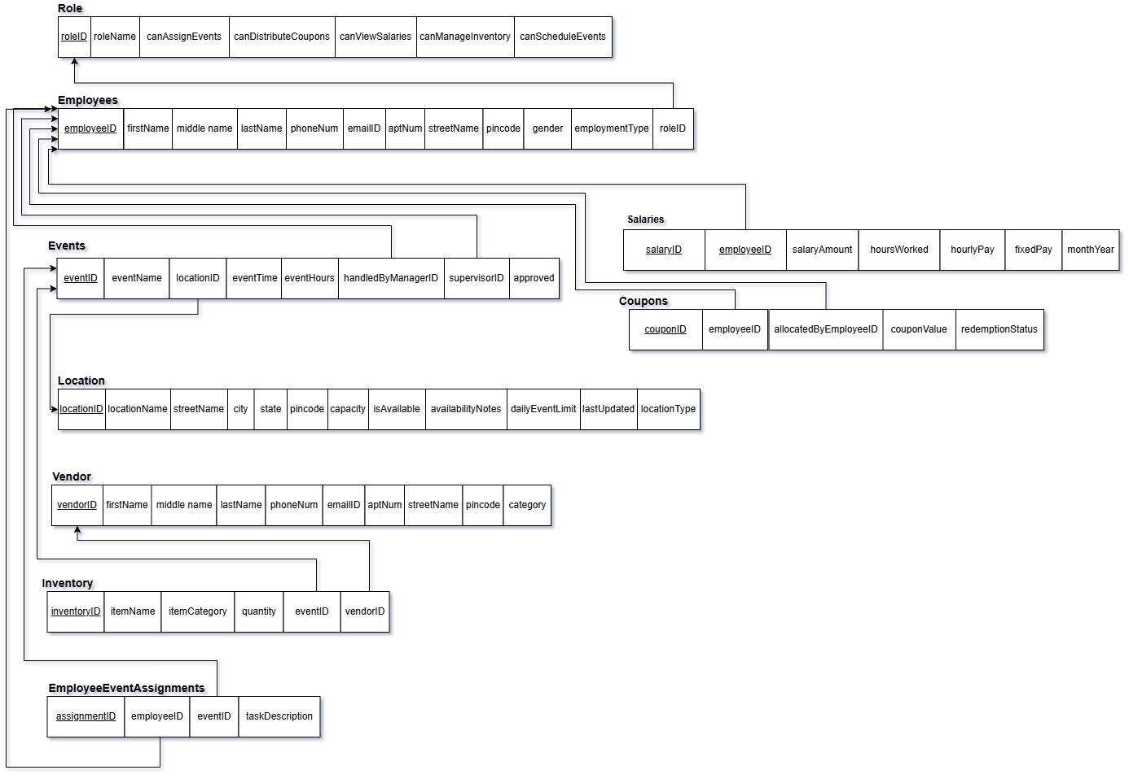

Entity-Relationship Diagram

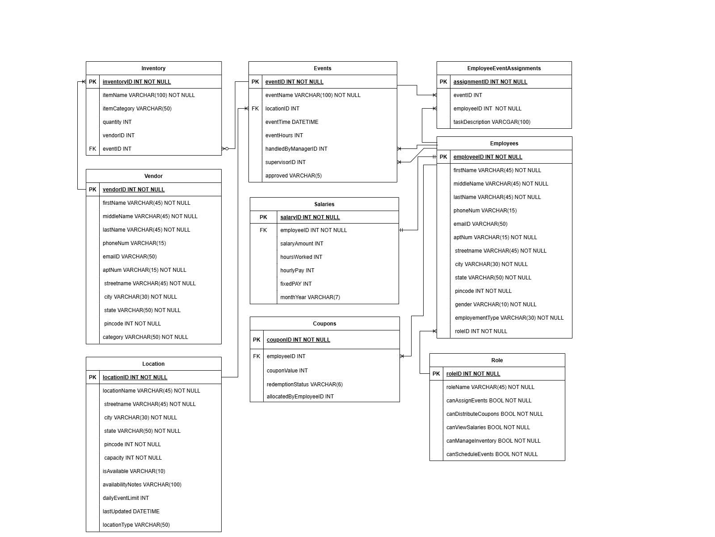

Data Dictionary

Employee Table
Attribute Name | Contents | Data Type | Format | Range | Required | PK or FK | FK Reference | Sample Data
employeeID | Unique identifier for the employee | INT | N/A | N/A | Y | PK | N/A | 2001
emailID | Employee's email address | VARCHAR(50) | Xxxxx@xxxx.xx | N/A | Y | N/A | N/A | john.doe@univ.com
firstName | Employee's first name | VARCHAR(45) | Xxxxxxxxxxx | N/A | Y | N/A | N/A | John
middleName | Employee's middle name | VARCHAR(45) | Xxxxxxxxxxx | N/A | N | N/A | N/A | David
lastName | Employee's last name | VARCHAR(45) | Xxxxxxxxxxx | N/A | Y | N/A | N/A | Doe
phoneNum | Employee's phone number | VARCHAR(15) | Xxxxxxxxxx | N/A | Y | N/A | N/A | 1234567890
aptNum | Employee's apartment number | VARCHAR(15) | Xxxxxxxxxxx | N/A | N | N/A | N/A | 12B
streetName | Employee's street name | VARCHAR(45) | Xxxxxxxxxxx | N/A | Y | N/A | N/A | Main Street
city | Employee's city | VARCHAR(30) | Xxxxxxxxxxx | N/A | Y | N/A | N/A | CityA
state | Employee's state | VARCHAR(30) | Xxxxxxxxxxx | N/A | Y | N/A | N/A | StateA
pincode | Postal code of employee's address | INT | Xxxxx | N/A | Y | N/A | N/A | 54321
gender | Employee's gender | VARCHAR(10) | Xxxxxxxx | N/A | Y | N/A | N/A | Male
employmentType | Employment type (Full-Time/Part-Time) | VARCHAR(30) | Xxxxxxxxxxx | N/A | Y | N/A | N/A | Full-Time
roleID | Role of the employee | INT | N/A | N/A | Y | FK | Role(roleID) | 1

Role Table
Attribute Name | Contents | Data Type | Format | Range | Required | PK or FK | FK Reference | Sample Data
roleID | Unique identifier for the role | INT | N/A | N/A | Y | PK | N/A | 1
roleName | Name of the role | VARCHAR(45) | Xxxxxxxxxxx | N/A | Y | N/A | N/A | Manager
canAssignEvents | Can assign events | BOOLEAN | TRUE/FALSE | N/A | Y | N/A | N/A | TRUE
canDistributeCoupons | Can distribute coupons | BOOLEAN | TRUE/FALSE | N/A | Y | N/A | N/A | TRUE
canViewSalaries | Can view salaries | BOOLEAN | TRUE/FALSE | N/A | Y | N/A | N/A | TRUE
canManageInventory | Can manage inventory | BOOLEAN | TRUE/FALSE | N/A | Y | N/A | N/A | TRUE
canScheduleEvents | Can schedule events | BOOLEAN | TRUE/FALSE | N/A | Y | N/A | N/A | TRUE

Events Table
Attribute Name | Contents | Data Type | Format | Range | Required | PK or FK | FK Reference | Sample Data
eventID | Unique identifier for the event | INT | N/A | N/A | Y | PK | N/A | 101
eventName | Name of the event | VARCHAR(100) | Xxxxxxxxxxx | N/A | Y | N/A | N/A | Annual Gala
locationID | Location of the event | INT | N/A | N/A | Y | FK | Location(locationID) | 1
eventTime | Date and time of the event | DATETIME | YYYY-MM-DD HH:MM | N/A | Y | N/A | N/A | 2024-12-01 18:00
eventHours | Total time of the event in hours | INT | N/A | 0 - 8 | Y | N/A | N/A | 5
handledByManagerID | Manager handling the event | INT | N/A | N/A | N | FK | Employee(employeeID) | 1
supervisorID | Supervisor of the event | INT | N/A | N/A | N | FK | Employee(employeeID) | 2
approved | Approval status of the event | VARCHAR(10) | Yes/No | N/A | Y | N/A | N/A | Yes

Location Table
Attribute Name | Contents | Data Type | Format | Range | Required | PK or FK | FK Reference | Sample Data
locationID | Unique identifier for the location | INT | N/A | N/A | Y | PK | N/A | 1
locationName | Name of the location | VARCHAR(45) | Xxxxxxxxxxx | N/A | Y | N/A | N/A | Main Hall
streetName | Street name of the location | VARCHAR(45) | Xxxxxxxxxxx | N/A | Y | N/A | N/A | First Ave
city | City where the location is situated | VARCHAR(30) | Xxxxxxxxxxx | N/A | Y | N/A | N/A | CityA
state | State where the location is situated | VARCHAR(30) | Xxxxxxxxxxx | N/A | Y | N/A | N/A | StateA
pincode | Postal code of the location | INT | Xxxxx | N/A | Y | N/A | N/A | 12345
capacity | Capacity of the location | INT | N/A | N/A | Y | N/A | N/A | 500
isAvailable | Availability status | VARCHAR(10) | TRUE/FALSE | N/A | Y | N/A | N/A | TRUE
availabilityNotes | Notes regarding availability | VARCHAR(100) | Xxxxxxxxxxx | N/A | N | N/A | N/A | Available for all events

Coupons Table
Attribute Name | Contents | Data Type | Format | Range | Required | PK or FK | FK Reference | Sample Data
couponID | Unique identifier for the coupon | INT | N/A | N/A | Y | PK | N/A | 301
employeeID | Employee receiving the coupon | INT | N/A | N/A | Y | FK | Employee(employeeID) | 2001
couponValue | Value of the coupon | INT | N/A | N/A | Y | N/A | N/A | 5
redemptionStatus | Status of coupon (Redeemed/Unredeemed) | VARCHAR(10) | Xxxxxxxxx | N/A | Y | N/A | N/A | Unredeemed
allocatedByEmployeeID | Employee allocating the coupon | INT | N/A | N/A | Y | FK | Employee(employeeID) | 2002

Salaries Table
Attribute Name | Contents | Data Type | Format | Range | Required | PK or FK | FK Reference | Sample Data
employeeID | Employee receiving the salary | INT | N/A | N/A | Y | PK, FK | Employee(employeeID) | 2001
salaryAmount | Total salary of the employee | INT | N/A | 0-99999 | Y | N/A | N/A | 5000
hoursWorked | Number of hours worked (for part-time) | INT | N/A | 0-40 | N | N/A | N/A | 20
hourlyPay | Hourly pay rate for part-time employees | INT | N/A | 0-100 | N | N/A | N/A | 25
fixedPay | Fixed salary for full-time employees | INT | N/A | 0-99999 | N | N/A | N/A | 5000

Vendor Table
Attribute Name | Contents | Data Type | Format | Range | Required | PK or FK | FK Reference | Sample Data
vendorID | Unique identifier for the vendor | INT | N/A | N/A | Y | PK | N/A | 501
firstName | Vendor's first name | VARCHAR(45) | Xxxxxxxxxxx | N/A | Y | N/A | N/A | Alice
middleName | Vendor's middle name | VARCHAR(45) | Xxxxxxxxxxx | N/A | N | N/A | N/A | NULL
lastName | Vendor's last name | VARCHAR(45) | Xxxxxxxxxxx | N/A | Y | N/A | N/A | Supplier
phoneNum | Vendor's phone number | VARCHAR(15) | Xxxxxxxxxx | N/A | Y | N/A | N/A | 1234567890
emailID | Vendor's email address | VARCHAR(50) | Xxxxx@xxxx.xx | N/A | Y | N/A | N/A | alice.supplier@xyz.com
aptNum | Vendor's apartment number | VARCHAR(15) | Xxxxxxxxxxx | N/A | N | N/A | N/A | 12A
streetName | Vendor's street name | VARCHAR(45) | Xxxxxxxxxxx | N/A | Y | N/A | N/A | Vendor Lane
city | Vendor's city | VARCHAR(30) | Xxxxxxxxxxx | N/A | Y | N/A | N/A | CityA
state | Vendor's state | VARCHAR(30) | Xxxxxxxxxxx | N/A | Y | N/A | N/A | StateA
pincode | Vendor's postal code | INT | Xxxxx | N/A | Y | N/A | N/A | 54321
category | Type of goods provided by the vendor | VARCHAR(50) | Xxxxxxxxxxx | N/A | Y | N/A | N/A | Food

Inventory Table
Attribute Name | Contents | Data Type | Format | Range | Required | PK or FK | FK Reference | Sample Data
inventoryID | Unique identifier for the inventory item | INT | N/A | N/A | Y | PK | N/A | 601
itemName | Name of the inventory item | VARCHAR(100) | Xxxxxxxxxxx | N/A | Y | N/A | N/A | Napkins
itemCategory | Category of the inventory item | VARCHAR(50) | Xxxxxxxxxxx | N/A | Y | N/A | N/A | Supplies
quantity | Quantity of the inventory item | INT | N/A | N/A | Y | N/A | N/A | 1000
vendorID | Vendor supplying the inventory item | INT | N/A | N/A | Y | FK | Vendor(vendorID) | 501
eventID | Event using the inventory item | INT | N/A | N/A | N | FK | Events(eventID) | 101

EmployeeEventAssignments Table
Attribute Name | Contents | Data Type | Format | Range | Required | PK or FK | FK Reference | Sample Data
assignmentID | Unique identifier for the assignment | INT | N/A | N/A | Y | PK | N/A | 701
employeeID | Employee assigned to the event | INT | N/A | N/A | Y | FK | Employee(employeeID) | 2001
eventID | Event to which the employee is assigned | INT | N/A | N/A | Y | FK | Events(eventID) | 101
taskDescription | Description of the assigned task | VARCHAR(100) | Xxxxxxxxxxx | N/A | N | N/A | N/A | Setup Venue

Implementation

Entity Generation and Data Entry
Connect to the SQL server and create a database with name - CateringServices

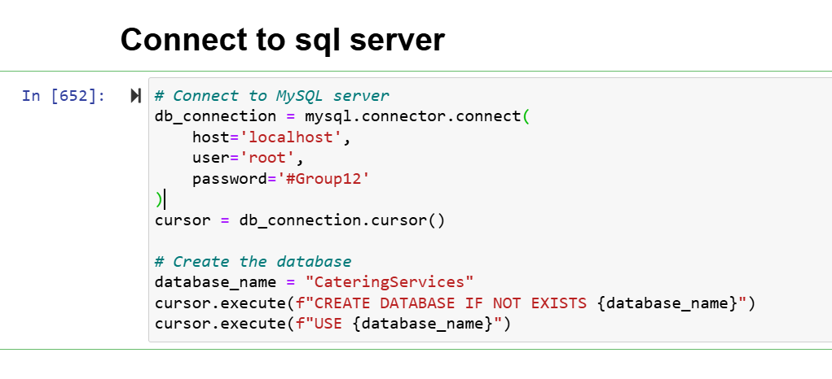
  - Employee Table Creation
SQL Statement –
"""
CREATE TABLE IF NOT EXISTS Employee (
employeeID INT AUTO_INCREMENT PRIMARY KEY,
firstName VARCHAR(45) NOT NULL,
middleName VARCHAR(45),
lastName VARCHAR(45) NOT NULL,
phoneNum VARCHAR(15) NOT NULL UNIQUE,
emailID VARCHAR(50) NOT NULL,
aptNum VARCHAR(15),
streetName VARCHAR(45),
city VARCHAR(30),
state VARCHAR(30),
pincode INT,
gender VARCHAR(10),
employmentType VARCHAR(30),
roleID INT NOT NULL,
FOREIGN KEY (roleID) REFERENCES Role(roleID)
)
"""

- Attributes of the Employee Table:
  - employeeID: Primary key, automatically increments for each new employee.
  - firstName, middleName, lastName: Store the employee's name.
  - phoneNum: A unique phone number for each employee.
  - emailID: Email address of the employee.
  - aptNum, streetName, city, state, pincode: Address details of the employee.
  - gender: Employee's gender.
  - employmentType: Specifies if the employee is full-time or part-time.
  - roleID: A foreign key referencing the Role table, linking the employee to their role.
- FOREIGN KEY (roleID) REFERENCES Role(roleID):
  - Ensures that every employee's role corresponds to a valid role in the Role table.

The Employee table is a core entity in a database used to store and manage detailed information about employees. It serves as a foundation for linking employee-related data with other parts of the system
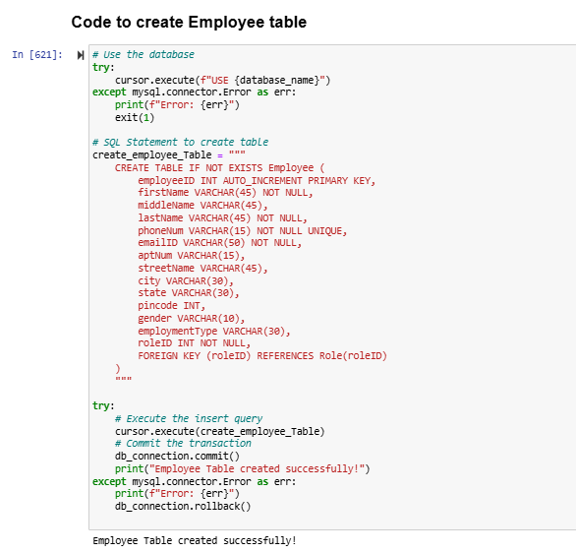

  - Role Table Creation
The Role table manages role-based access control by defining:
- Roles: Names of distinct roles in the system (e.g., Manager, Supervisor, Non-Supervisor).
- Permissions: Boolean flags that indicate what actions each role can perform.
- Attributes in the Role Table:
  - roleID: Primary key (PRIMARY KEY) for uniquely identifying each role. Auto-increments for every new role.
  - roleName: Name of the role (e.g., Manager, Supervisor). Must be unique (UNIQUE) to prevent duplicate roles.
  - canAssignEvents: A BOOLEAN value indicating whether this role has permission to assign events.
  - canDistributeCoupons: A BOOLEAN value indicating whether this role can distribute coupons.
  - canViewSalaries: A BOOLEAN value indicating whether this role can view employee salaries.
  - canManageInventory: A BOOLEAN value indicating whether this role can manage inventory.
  - canScheduleEvents: A BOOLEAN value indicating whether this role can schedule events.
SQL Statement –
"""
CREATE TABLE IF NOT EXISTS Role (
roleID INT AUTO_INCREMENT PRIMARY KEY,
roleName VARCHAR(45) NOT NULL UNIQUE,
canAssignEvents BOOLEAN NOT NULL,
canDistributeCoupons BOOLEAN NOT NULL,
canViewSalaries BOOLEAN NOT NULL,
canManageInventory BOOLEAN NOT NULL,
canScheduleEvents BOOLEAN NOT NULL
)
"""
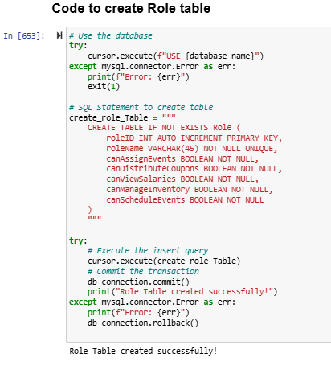

  - Location Table Creation
The Location table manages all information about venues used for events. It helps track attributes like capacity, availability, and event limitations.
- Attributes in the Location Table:
  - locationID: Primary key (PRIMARY KEY) for uniquely identifying each location. Auto-incremented for every new location.
  - locationName: Stores the name of the location (e.g., Main Hall, Conference Room).
  - streetName, city, state, pincode, Store the address details of the location.
  - capacity: Specifies the maximum number of attendees the location can accommodate.
  - isAvailable: Indicates whether the location is currently available (e.g., Yes/No).
  - availabilityNotes: Provides additional notes about availability (e.g., under maintenance).
  - dailyEventLimit: Specifies the maximum number of events the location can host in a single day.
  - lastUpdated: Tracks the last time the location's information was updated.
  - locationType: Describes the type of location (e.g., Indoor, Outdoor, Amphitheater).
SQL Statement –
"""
CREATE TABLE IF NOT EXISTS Location (
locationID INT AUTO_INCREMENT PRIMARY KEY,
locationName VARCHAR(45) NOT NULL,
streetName VARCHAR(45),
city VARCHAR(30),
state VARCHAR(30),
pincode INT,
capacity INT NOT NULL,
isAvailable VARCHAR(10),
availabilityNotes VARCHAR(100),
dailyEventLimit INT,
lastUpdated DATETIME,
"""

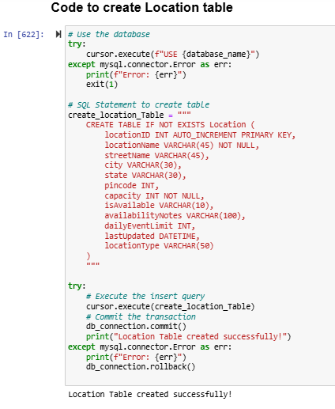

  - Event Table Creation
Creates the Events table to store event details, such as event name, location, time, duration, and assigned staff. Manages event scheduling and assignment of staff to locations.
Attributes Explanation:
- eventID: Primary key for uniquely identifying each event.
- eventName: Name of the event.
- locationID: Foreign key referencing the Location table.
- eventTime: Date and time of the event.
- eventHours: Duration of the event in hours.
- handledByManagerID and supervisorID: Foreign keys referencing Employee table to associate the manager and supervisor.
- approved: Indicates whether the event has been approved.
SQL Statement –
"""
CREATE TABLE IF NOT EXISTS Events (
eventID INT AUTO_INCREMENT PRIMARY KEY,
eventName VARCHAR(100) NOT NULL,
locationID INT NOT NULL,
eventTime DATETIME NOT NULL,
eventHours INT NOT NULL,
handledByManagerID INT,
supervisorID INT,
approved VARCHAR(10) ,
FOREIGN KEY (locationID) REFERENCES Location(locationID),
FOREIGN KEY (handledByManagerID) REFERENCES Employee(employeeID),
FOREIGN KEY (supervisorID) REFERENCES Employee(employeeID)
)
"""
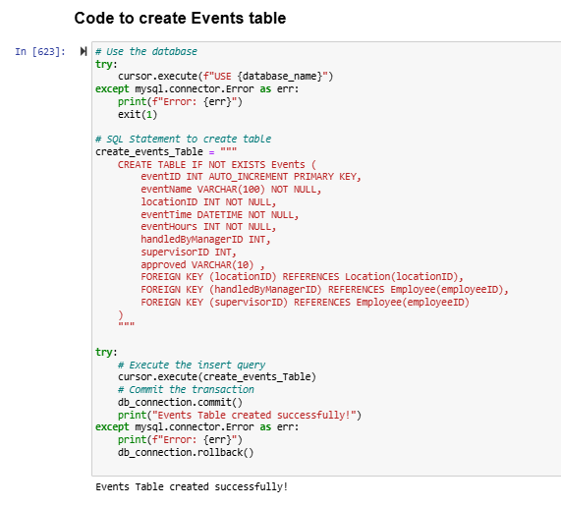

  - Coupons Table Creation
Creates the Coupons table to manage coupons distributed to employees as rewards or incentives. Tracks coupons given to employees for specific tasks or performance.
Attributes Explanation:
- couponID: Primary key for uniquely identifying each coupon.
- employeeID: Foreign key referencing the Employee table to associate the coupon with an employee.
- couponValue: Monetary value of the coupon.
- redemptionStatus: Status of the coupon (e.g., redeemed or unredeemed).
- allocatedByEmployeeID: Foreign key referencing Employee table to track who allocated the coupon.
SQL Statement –
"""
CREATE TABLE IF NOT EXISTS Coupons (
couponID INT AUTO_INCREMENT PRIMARY KEY,
employeeID INT NOT NULL,
couponValue INT NOT NULL,
redemptionStatus VARCHAR(15),
allocatedByEmployeeID INT,
FOREIGN KEY (employeeID) REFERENCES Employee(employeeID),
FOREIGN KEY (allocatedByEmployeeID) REFERENCES Employee(employeeID)
)
"""

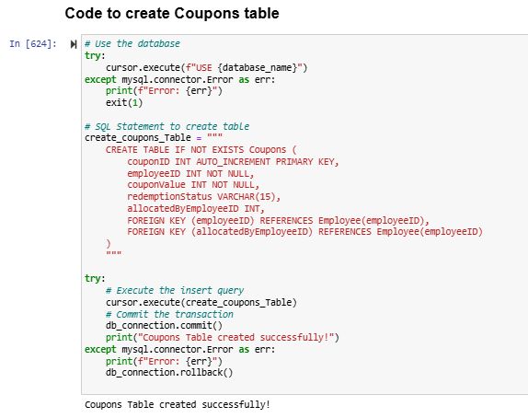
  - Salaries Table Creation
Creates the Salaries table to manage salary records for employees. Tracks employee compensation based on hours worked and salary type.
Attributes Explanation:
- salaryID: Primary key for uniquely identifying each salary record.
- employeeID: Foreign key referencing Employee table to associate the salary with an employee.
- salaryAmount: Total salary amount for a given month.
- hoursWorked: Number of hours worked by the employee.
- hourlyPay and fixedPay: Hourly pay for part-time and fixed yearly pay for full-time employees.
- monthYear: Tracks the salary period (e.g., '2024-12').
- UNIQUE (employeeID, monthYear): Ensures an employee has only one salary entry per month.
SQL Statement –
"""
CREATE TABLE IF NOT EXISTS Salaries (
salaryID INT AUTO_INCREMENT PRIMARY KEY, -- Unique identifier for salary records
employeeID INT NOT NULL, -- Foreign key referencing Employee table
salaryAmount INT,
hoursWorked INT,
hourlyPay INT,
fixedPay INT,
monthYear VARCHAR(7), -- Tracks salary period (e.g., '2024-11')
UNIQUE (employeeID, monthYear), -- Ensures each employee gets one salary entry per month
FOREIGN KEY (employeeID) REFERENCES Employee(employeeID)
)
"""

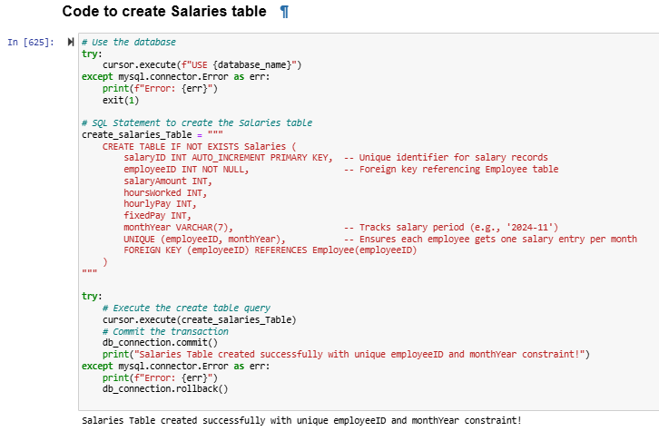

  - Vendor Table Creation
Creates the Vendor table to store details about vendors supplying goods and services. Manages vendor information for procurement and supply chain operations.
Attributes Explanation:
- vendorID: Primary key for uniquely identifying each vendor.
- firstName, middleName, lastName: Vendor's name.
- phoneNum and emailID: Vendor contact details.
- aptNum, streetName, city, state, pincode: Vendor address.
- category: Type of goods or services provided by the vendor (e.g., food, beverage).
SQL Statement –
"""
CREATE TABLE IF NOT EXISTS Vendor (
vendorID INT AUTO_INCREMENT PRIMARY KEY,
firstName VARCHAR(45),
middleName VARCHAR(45),
lastName VARCHAR(45),
phoneNum VARCHAR(15),
emailID VARCHAR(50),
aptNum VARCHAR(15),
streetName VARCHAR(45),
city VARCHAR(30),
state VARCHAR(50),
pincode INT,
category VARCHAR(50)
)
"""
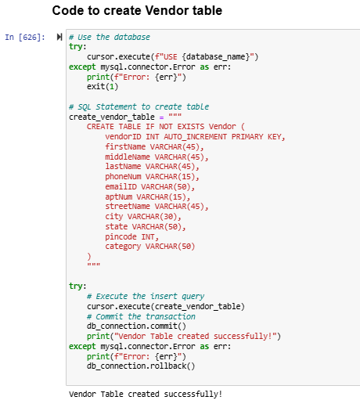
  - Inventory Table Creation
Creates the Inventory table to track items used in events. Tracks inventory levels and assigns items to events when needed.
Attributes Explanation:
- inventoryID: Primary key for uniquely identifying each inventory item.
- itemName: Name of the inventory item.
- itemCategory: Category of the item (e.g., supplies, beverages).
- quantity: Quantity of the item in stock.
- vendorID: Foreign key referencing Vendor table.
- eventID: Foreign key referencing Events table, if the item is associated with a specific event.
SQL Statement –
"""
CREATE TABLE IF NOT EXISTS Inventory (
inventoryID INT AUTO_INCREMENT PRIMARY KEY,
itemName VARCHAR(100) NOT NULL,
itemCategory VARCHAR(50),
quantity INT NOT NULL,
vendorID INT NOT NULL,
eventID INT,
FOREIGN KEY (vendorID) REFERENCES Vendor(vendorID),
FOREIGN KEY (eventID) REFERENCES Events(eventID)
)
"""
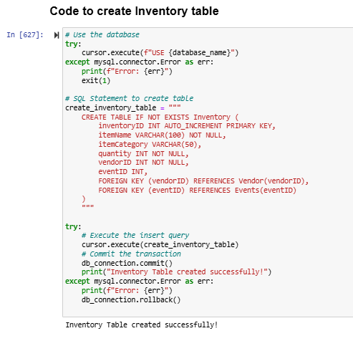
  - EmployeeEventAssignments Table Creation
Creates the EmployeeEventAssignments table to track which employees are assigned to specific events. Tracks employee participation and tasks assigned for events.
Attributes Explanation:
- assignmentID: Primary key for uniquely identifying each assignment.
- employeeID: Foreign key referencing Employee table to associate an employee with an event.
- eventID: Foreign key referencing Events table to link the assignment to an event.
- taskDescription: Description of the task assigned to the employee.
- UNIQUE (employeeID, eventID): Ensures an employee can only be assigned to an event once.
SQL Statement –
"""
CREATE TABLE IF NOT EXISTS EmployeeEventAssignments (
assignmentID INT AUTO_INCREMENT PRIMARY KEY,
employeeID INT NOT NULL,
eventID INT NOT NULL,
taskDescription VARCHAR(100),
FOREIGN KEY (employeeID) REFERENCES Employee(employeeID),
FOREIGN KEY (eventID) REFERENCES Events(eventID),
UNIQUE (employeeID, eventID) -- Ensures unique combinations
)
"""
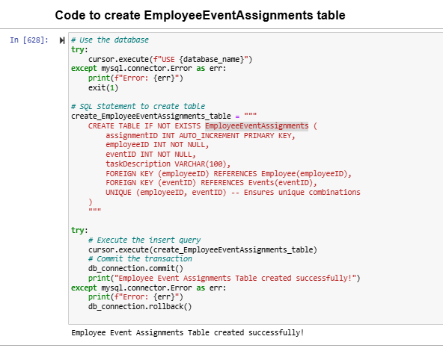

  - Employee table data insertion
Sql statement inserts data into tables
SQL Statement –
"""
INSERT INTO Employee (employeeID, firstName, middleName, lastName, phoneNum, emailID, aptNum, streetName, city, state, pincode, gender, employmentType, roleID)
VALUES
(1, 'John', 'M', 'Doe', '1234567890', 'john.doe@example.com', '1A', 'Main Street', 'Denton', 'Texas', 76201, 'Male', 'Full-Time', 1),
(2, 'Jane', 'A', 'Smith', '1234567891', 'jane.smith@example.com', '2B', 'Elm Street', 'Frisco', 'Texas', 75033, 'Female', 'Part-Time', 4),
(3, 'Robert', 'B', 'Johnson', '1234567892', 'robert.johnson@example.com', '3C', 'Pine Street', 'Aubrey', 'Texas', 76227, 'Male', 'Full-Time', 2),
(4, 'Alice', NULL, 'Brown', '1234567893', 'alice.brown@example.com', NULL, 'Oak Street', 'Plano', 'Texas', 75023, 'Female', 'Full-Time', 3),
(5, 'Michael', NULL, 'Davis', '1234567894', 'michael.davis@example.com', '5D', 'Maple Street', 'Dallas', 'Texas', 75201, 'Male', 'Part-Time', 4),
(6, 'Emily', 'J', 'Clark', '1234567895', 'emily.clark@example.com', '6E', 'Cedar Street', 'Denton', 'Texas', 76202, 'Female', 'Full-Time', 1),
(7, 'Chris', 'L', 'Evans', '1234567896', 'chris.evans@example.com', NULL, 'Birch Street', 'Frisco', 'Texas', 75034, 'Male', 'Full-Time', 2),
(8, 'Sarah', NULL, 'Wilson', '1234567897', 'sarah.wilson@example.com', '8F', 'Ash Street', 'Aubrey', 'Texas', 76228, 'Female', 'Part-Time', 4),
(9, 'David', 'A', 'Taylor', '1234567898', 'david.taylor@example.com', '9G', 'Spruce Street', 'Plano', 'Texas', 75024, 'Male', 'Full-Time', 3),
(10, 'Laura', 'K', 'Martinez', '1234567899', 'laura.martinez@example.com', NULL, 'Willow Street', 'Dallas', 'Texas', 75202, 'Female', 'Full-Time', 1),
(11, 'Daniel', 'P', 'Garcia', '12345678910', 'daniel.garcia@example.com', '10H', 'Oak Drive', 'Denton', 'Texas', 76203, 'Male', 'Part-Time', 4),
(12, 'Sophia', NULL, 'Miller', '12345678911', 'sophia.miller@example.com', '11I', 'Cypress Lane', 'Frisco', 'Texas', 75035, 'Female', 'Part-Time', 4),
(13, 'Ethan', 'Q', 'Rodriguez', '12345678912', 'ethan.rodriguez@example.com', '12J', 'Hickory Road', 'Aubrey', 'Texas', 76229, 'Male', 'Full-Time', 3),
(14, 'Olivia', 'R', 'Martinez', '12345678913', 'olivia.martinez@example.com', '13K', 'Aspen Way', 'Plano', 'Texas', 75025, 'Female', 'Part-Time', 4),
(15, 'Benjamin', NULL, 'Lee', '12345678914', 'benjamin.lee@example.com', NULL, 'Sequoia Blvd', 'Dallas', 'Texas', 75203, 'Male', 'Part-Time', 4),
(16, 'Emma', 'S', 'Perez', '12345678915', 'emma.perez@example.com', '14L', 'Magnolia Street', 'Denton', 'Texas', 76204, 'Female', 'Full-Time', 2),
(17, 'Noah', NULL, 'Moore', '12345678916', 'noah.moore@example.com', '15M', 'Cedar Grove', 'Frisco', 'Texas', 75036, 'Male', 'Full-Time', 3),
(18, 'Isabella', 'T', 'Flores', '12345678917', 'isabella.flores@example.com', '16N', 'Elm Grove', 'Aubrey', 'Texas', 76230, 'Female', 'Full-Time', 1),
(19, 'James', NULL, 'Anderson', '12345678918', 'james.anderson@example.com', '17O', 'Birch Trail', 'Plano', 'Texas', 75026, 'Male', 'Part-Time', 4),
(20, 'Charlotte', 'U', 'Lopez', '12345678919', 'charlotte.lopez@example.com', NULL, 'Palm Way', 'Dallas', 'Texas', 75204, 'Female', 'Full-Time', 2),
(21, 'Alexander', NULL, 'King', '12345678920', 'alexander.king@example.com', '18P', 'Maple Trail', 'Denton', 'Texas', 76205, 'Male', 'Part-Time', 4),
(22, 'Amelia', 'V', 'Scott', '12345678921', 'amelia.scott@example.com', '19Q', 'Hickory Lane', 'Frisco', 'Texas', 75037, 'Female', 'Part-Time', 4),
(23, 'Mason', NULL, 'Torres', '12345678922', 'mason.torres@example.com', NULL, 'Spruce Drive', 'Aubrey', 'Texas', 76231, 'Male', 'Full-Time', 1),
(24, 'Harper', 'W', 'Nguyen', '12345678923', 'harper.nguyen@example.com', '20R', 'Cypress Trail', 'Plano', 'Texas', 75027, 'Female', 'Part-Time', 4),
(25, 'Elijah', 'X', 'Garcia', '12345678924', 'elijah.garcia@example.com', '21S', 'Sequoia Blvd', 'Dallas', 'Texas', 75205, 'Male', 'Part-Time', 4),
(26, 'Abigail', 'Y', 'Brown', '12345678925', 'abigail.brown@example.com', '22T', 'Aspen Avenue', 'Denton', 'Texas', 76206, 'Female', 'Full-Time', 1),
(27, 'Henry', NULL, 'Clark', '12345678926', 'henry.clark@example.com', NULL, 'Maple Road', 'Frisco', 'Texas', 75038, 'Male', 'Part-Time', 4),
(28, 'Sofia', 'Z', 'Lopez', '12345678927', 'sofia.lopez@example.com', '23U', 'Oakwood Drive', 'Aubrey', 'Texas', 76232, 'Female', 'Full-Time', 2),
(29, 'William', NULL, 'Jones', '12345678928', 'william.jones@example.com', '24V', 'Pine Circle', 'Plano', 'Texas', 75028, 'Male', 'Part-Time', 4),
(30, 'Mia', 'A', 'Scott', '12345678929', 'mia.scott@example.com', '25W', 'Cypress Avenue', 'Dallas', 'Texas', 75206, 'Female', 'Full-Time', 3)
"""
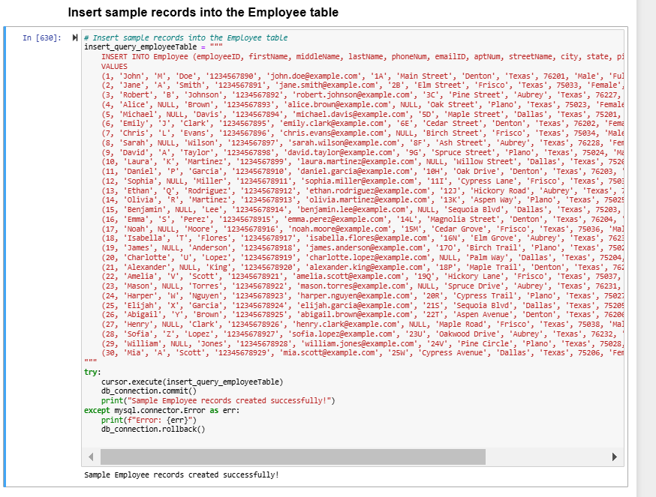
  - Role table data insertion
Sql statement inserts data into tables
SQL Statement –
"""
INSERT INTO Role (roleName, canAssignEvents, canDistributeCoupons, canViewSalaries, canManageInventory, canScheduleEvents)
VALUES
('Manager', TRUE, TRUE, TRUE, TRUE, TRUE),
('Supervisor', FALSE, TRUE, FALSE, TRUE, TRUE),
('Non-Supervisor', FALSE, FALSE, FALSE, FALSE, FALSE),
('PartTime-Employee', FALSE, FALSE, FALSE, FALSE, FALSE)
"""

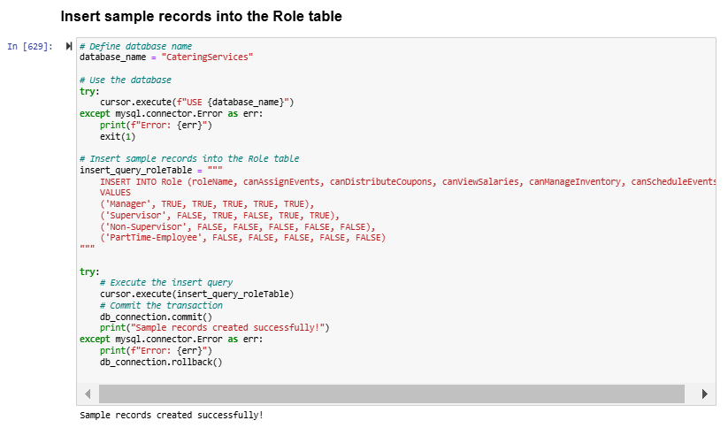
  - Location table data insertion
Sql statement inserts data into tables
SQL Statement –
"""
INSERT INTO Location (locationName, streetName, city, state, pincode, capacity, isAvailable, availabilityNotes, dailyEventLimit, lastUpdated, locationType)
VALUES
('Main Hall', 'First Ave', 'Denton', 'Texas', 76201, 500, 'Yes', 'Available for all events', 3, NOW(), 'Indoor'),
('Conference Room', 'Second Ave', 'Denton', 'Texas', 76202, 200, 'Yes', 'Equipped with projectors', 2, NOW(), 'Indoor'),
('Outdoor Park', 'Park Lane', 'Denton', 'Texas', 76203, 1000, 'No', 'Under Maintenance', 5, NOW(), 'Outdoor'),
('Banquet Hall', 'Third Ave', 'Frisco', 'Texas', 75033, 300, 'Yes', 'Ideal for weddings', 4, NOW(), 'Indoor'),
('Sports Ground', 'Fourth Ave', 'Frisco', 'Texas', 75034, 1500, 'Yes', 'Available for sports events', 5, NOW(), 'Outdoor'),
('Community Center', 'Fifth Ave', 'Frisco', 'Texas', 75035, 400, 'Yes', 'Used for meetings', 3, NOW(), 'Indoor'),
('Town Hall', 'Sixth Ave', 'Aubrey', 'Texas', 76227, 800, 'Yes', 'Open for public events', 3, NOW(), 'Indoor'),
('Open Air Stage', 'Seventh Ave', 'Aubrey', 'Texas', 76228, 1200, 'Yes', 'Available for concerts', 4, NOW(), 'Outdoor'),
('Gallery', 'Eighth Ave', 'Aubrey', 'Texas', 76229, 200, 'Yes', 'For exhibitions', 2, NOW(), 'Indoor'),
('Training Center', 'Ninth Ave', 'Plano', 'Texas', 75023, 250, 'Yes', 'For training sessions', 2, NOW(), 'Indoor'),
('Exhibition Hall', 'Tenth Ave', 'Plano', 'Texas', 75024, 600, 'No', 'Reserved for expo', 3, NOW(), 'Indoor'),
('Sports Complex', 'Eleventh Ave', 'Plano', 'Texas', 75025, 2000, 'Yes', 'Available for sports events', 6, NOW(), 'Outdoor'),
('Convention Center', 'Twelfth Ave', 'Dallas', 'Texas', 75201, 1500, 'Yes', 'For conventions', 5, NOW(), 'Indoor'),
('Lecture Hall', 'Thirteenth Ave', 'Dallas', 'Texas', 75202, 250, 'Yes', 'Used for seminars', 2, NOW(), 'Indoor'),
('Stadium', 'Fourteenth Ave', 'Dallas', 'Texas', 75203, 3000, 'Yes', 'Open for large events', 6, NOW(), 'Outdoor'),
('Amphitheater', 'Fifteenth Ave', 'Denton', 'Texas', 76204, 800, 'Yes', 'Ideal for plays', 3, NOW(), 'Outdoor'),
('Library Hall', 'Sixteenth Ave', 'Denton', 'Texas', 76205, 150, 'Yes', 'Available for meetings', 2, NOW(), 'Indoor'),
('Science Center', 'Seventeenth Ave', 'Frisco', 'Texas', 75036, 600, 'No', 'Under Renovation', 3, NOW(), 'Indoor'),
('Music Hall', 'Eighteenth Ave', 'Frisco', 'Texas', 75037, 400, 'Yes', 'For music recitals', 3, NOW(), 'Indoor'),
('Green Park', 'Nineteenth Ave', 'Aubrey', 'Texas', 76230, 1000, 'Yes', 'Available for public events', 5, NOW(), 'Outdoor'),
('Auditorium', 'Twentieth Ave', 'Aubrey', 'Texas', 76231, 700, 'Yes', 'Ideal for conferences', 3, NOW(), 'Indoor'),
('Cinema Hall', 'Twenty-First Ave', 'Plano', 'Texas', 75026, 300, 'Yes', 'Available for film events', 2, NOW(), 'Indoor'),
('Playground', 'Twenty-Second Ave', 'Plano', 'Texas', 75027, 1200, 'Yes', 'Open for recreational events', 5, NOW(), 'Outdoor'),
('Sports Pavilion', 'Twenty-Third Ave', 'Dallas', 'Texas', 75204, 800, 'Yes', 'For sports and games', 4, NOW(), 'Outdoor'),
('Art Gallery', 'Twenty-Fourth Ave', 'Dallas', 'Texas', 75205, 300, 'Yes', 'For art exhibitions', 2, NOW(), 'Indoor'),
('Tech Center', 'Twenty-Fifth Ave', 'Denton', 'Texas', 76206, 600, 'Yes', 'For tech expos', 3, NOW(), 'Indoor'),
('Community Hall', 'Twenty-Sixth Ave', 'Frisco', 'Texas', 75038, 200, 'Yes', 'For community events', 2, NOW(), 'Indoor'),
('Riverfront Stage', 'Twenty-Seventh Ave', 'Aubrey', 'Texas', 76232, 900, 'Yes', 'For open-air performances', 4, NOW(), 'Outdoor'),
('Boardroom', 'Twenty-Eighth Ave', 'Plano', 'Texas', 75028, 100, 'Yes', 'For corporate meetings', 2, NOW(), 'Indoor'),
('Outdoor Arena', 'Twenty-Ninth Ave', 'Dallas', 'Texas', 75206, 2500, 'No', 'Reserved for private events', 5, NOW(), 'Outdoor')
"""
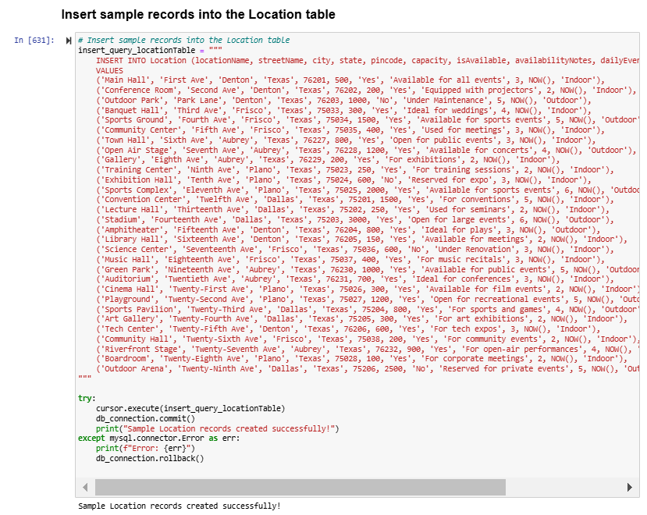
  - Events table data insertion
Sql statement inserts data into tables
SQL Statement –
"""
INSERT INTO Events (eventName, locationID, eventTime, eventHours, handledByManagerID, supervisorID, approved)
VALUES
('Annual Gala', 1, '2024-07-01 18:00:00', 4, 1, 2, 'Yes'),
('Tech Conference', 2, '2024-07-05 09:00:00', 6, 1, 3, 'Yes'),
('Music Festival', 3, '2024-07-10 16:00:00', 8, 2, 4, 'No'),
('Wedding Reception', 4, '2024-07-15 19:00:00', 5, 3, 5, 'Yes'),
('Sports Meet', 5, '2024-07-20 08:00:00', 7, 1, 2, 'Yes'),
('Food Expo', 6, '2024-08-01 12:00:00', 3, 2, 3, 'Yes'),
('Charity Ball', 7, '2024-08-05 19:30:00', 4, 1, 4, 'Yes'),
('Corporate Meetup', 8, '2024-08-10 10:00:00', 6, 2, 5, 'Yes'),
('Art Exhibition', 9, '2024-08-15 14:00:00', 2, 3, 2, 'Yes'),
('Product Launch', 10, '2024-08-20 11:00:00', 7, 1, 3, 'Yes'),
('Town Hall Meeting', 11, '2024-08-25 17:00:00', 3, 2, 4, 'No'),
('Music Recital', 12, '2024-09-01 15:00:00', 8, 3, 5, 'Yes'),
('Book Fair', 13, '2024-09-05 09:00:00', 6, 1, 2, 'Yes'),
('Film Screening', 14, '2024-09-10 20:00:00', 5, 2, 3, 'Yes'),
('Training Workshop', 15, '2024-09-15 10:00:00', 4, 3, 4, 'Yes'),
('Open Mic Night', 16, '2024-09-20 19:00:00', 3, 1, 5, 'No'),
('Hackathon', 17, '2024-09-25 08:00:00', 7, 2, 2, 'Yes'),
('Startup Showcase', 18, '2024-10-01 11:30:00', 8, 3, 3, 'Yes'),
('Science Fair', 19, '2024-10-05 10:00:00', 5, 1, 4, 'Yes'),
('Cultural Fest', 20, '2024-10-10 17:00:00', 6, 2, 5, 'Yes'),
('Sports Day', 21, '2024-10-15 09:00:00', 3, 3, 2, 'Yes'),
('Networking Event', 22, '2024-10-20 13:00:00', 2, 1, 3, 'No'),
('Team Building Retreat', 23, '2024-10-25 09:00:00', 4, 2, 4, 'Yes'),
('Fundraiser', 24, '2024-11-01 18:00:00', 7, 3, 5, 'Yes'),
('Gaming Tournament', 25, '2024-11-05 10:00:00', 8, 1, 2, 'Yes'),
('Halloween Party', 26, '2024-11-10 19:00:00', 6, 2, 3, 'Yes'),
('Business Conference', 27, '2024-11-15 11:00:00', 4, 3, 4, 'Yes'),
('Holiday Market', 28, '2024-11-20 15:00:00', 5, 1, 5, 'No'),
('Cooking Contest', 29, '2024-11-25 10:00:00', 3, 2, 2, 'Yes'),
('Thanksgiving Feast', 30, '2024-11-30 18:30:00', 6, 3, 3, 'Yes'),
('Annual Conference', 1, '2024-12-01 08:00:00', 8, 1, 4, 'Yes'),
('Winter Concert', 2, '2024-12-05 19:00:00', 5, 2, 5, 'Yes'),
('Company Dinner', 3, '2024-12-10 18:00:00', 3, 3, 2, 'Yes'),
('Winter Carnival', 4, '2024-12-15 10:00:00', 4, 1, 3, 'Yes'),
('Christmas Party', 5, '2024-12-20 20:00:00', 6, 2, 4, 'Yes'),
('New Year Bash', 6, '2024-12-25 23:00:00', 8, 3, 5, 'Yes'),
('Dance Festival', 7, '2024-07-15 18:30:00', 4, 1, 2, 'Yes'),
('Poetry Slam', 8, '2024-08-20 15:30:00', 5, 2, 3, 'Yes'),
('Volunteer Meetup', 9, '2024-09-12 09:30:00', 3, 3, 4, 'No'),
('Marketing Expo', 10, '2024-10-08 14:00:00', 7, 1, 5, 'Yes'),
('Literature Fest', 11, '2024-11-02 12:00:00', 6, 2, 2, 'Yes'),
('Robotics Fair', 12, '2024-12-11 13:00:00', 8, 3, 3, 'Yes'),
('Debate Tournament', 13, '2024-11-30 16:30:00', 4, 1, 4, 'Yes'),
('Music Jam', 14, '2024-08-05 19:30:00', 3, 2, 5, 'Yes'),
('Health Seminar', 15, '2024-07-22 10:00:00', 6, 3, 2, 'Yes'),
('Tech Meetup', 16, '2024-09-18 14:00:00', 5, 1, 3, 'Yes'),
('Environmental Summit', 17, '2024-10-22 10:00:00', 4, 2, 4, 'No'),
('Employee Appreciation Night', 18, '2024-11-28 19:00:00', 7, 3, 5, 'Yes'),
('Culinary Show', 19, '2024-12-12 18:30:00', 8, 1, 2, 'Yes'),
('Research Symposium', 20, '2024-12-14 09:00:00', 6, 2, 3, 'Yes')
"""
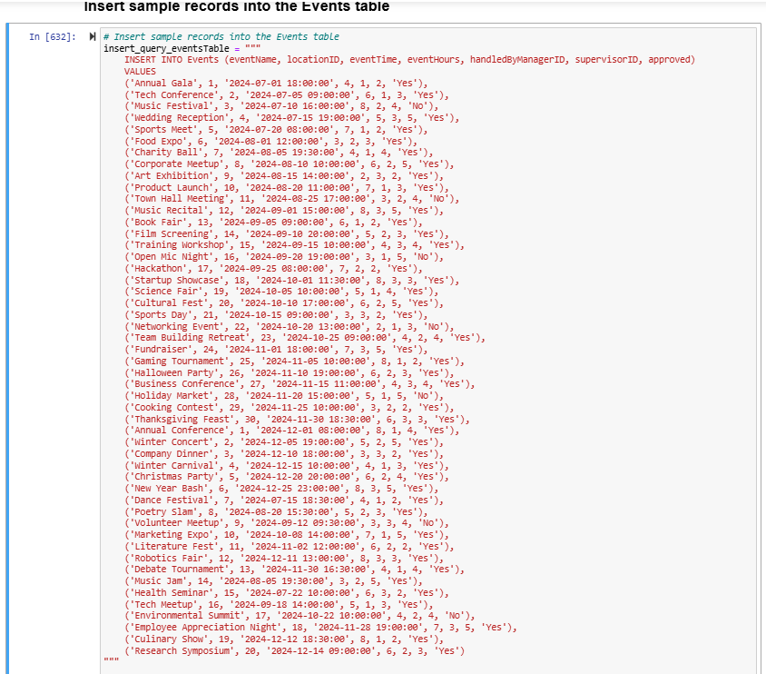
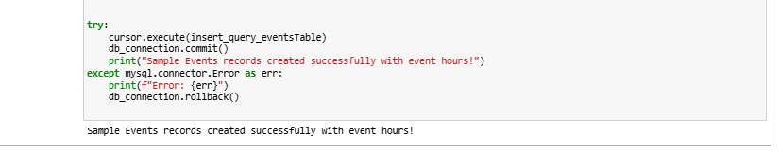

  - Coupons table data insertion
Sql statement inserts data into tables
SQL Statement –
"""
INSERT INTO Coupons (employeeID, couponValue, redemptionStatus, allocatedByEmployeeID)
VALUES
(2, 5, 'Unredeemed', 1),
(5, 9, 'Redeemed', 2),
(8, 5, 'Unredeemed', 3),
(12, 9, 'Redeemed', 4),
(15, 5, 'Unredeemed', 5),
(19, 9, 'Redeemed', 1),
(21, 5, 'Unredeemed', 2),
(22, 9, 'Redeemed', 3),
(25, 5, 'Unredeemed', 4),
(27, 9, 'Redeemed', 5),
(11, 5, 'Unredeemed', 1),
(8, 9, 'Redeemed', 2),
(12, 5, 'Unredeemed', 3),
(15, 9, 'Redeemed', 4),
(19, 5, 'Unredeemed', 5),
(21, 9, 'Redeemed', 1),
(22, 5, 'Unredeemed', 2),
(25, 9, 'Redeemed', 3),
(29, 5, 'Unredeemed', 4),
(21, 9, 'Redeemed', 5),
(2, 5, 'Unredeemed', 1),
(5, 9, 'Redeemed', 2),
(8, 5, 'Unredeemed', 3),
(12, 9, 'Redeemed', 4),
(15, 5, 'Unredeemed', 5),
(19, 9, 'Redeemed', 1),
(21, 5, 'Unredeemed', 2),
(22, 9, 'Redeemed', 3),
(25, 5, 'Unredeemed', 4),
(27, 9, 'Redeemed', 5),
(11, 5, 'Unredeemed', 1),
(2, 9, 'Redeemed', 2),
(5, 5, 'Unredeemed', 3),
(8, 9, 'Redeemed', 4),
(12, 5, 'Unredeemed', 5),
(15, 9, 'Redeemed', 1),
(19, 5, 'Unredeemed', 2),
(21, 9, 'Redeemed', 3),
(22, 5, 'Unredeemed', 4),
(25, 9, 'Redeemed', 5)
"""
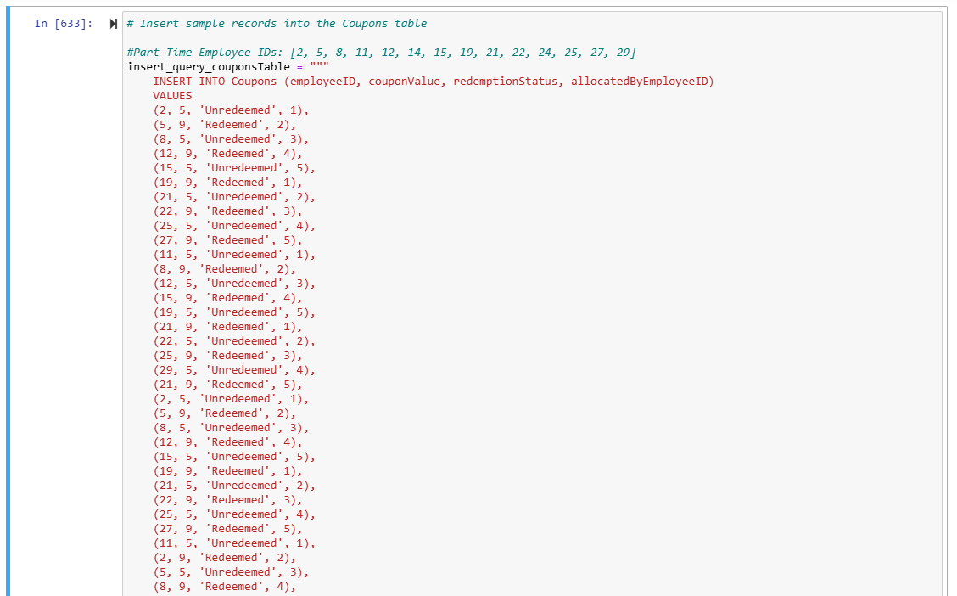
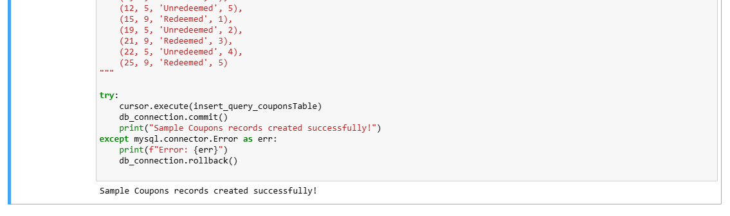
  - Salaries table data insertion
Sql statement inserts data into tables
SQL Statement –
"""
INSERT INTO Salaries (employeeID, salaryAmount, hoursWorked, hourlyPay, fixedPay, monthYear)
VALUES
-- Full-Time Employees (Fixed Pay is yearly, Salary Amount is monthly)
(1, 4166.67, NULL, NULL, 50000, '2024-11'), -- 50000/12 = 4166.67
(3, 3750.00, NULL, NULL, 45000, '2024-11'), -- 45000/12 = 3750.00
(4, 4000.00, NULL, NULL, 48000, '2024-11'), -- 48000/12 = 4000.00
(6, 4166.67, NULL, NULL, 50000, '2024-11'), -- Another Full-Time Employee
(10, 3750.00, NULL, NULL, 45000, '2024-11'), -- Another Full-Time Employee
(1, 4166.67, NULL, NULL, 50000, '2024-12'), -- Monthly salary for December
(3, 3750.00, NULL, NULL, 45000, '2024-12'),
(4, 4000.00, NULL, NULL, 48000, '2024-12'),
(6, 4166.67, NULL, NULL, 50000, '2024-12'),
(10, 3750.00, NULL, NULL, 45000, '2024-12'),

-- Part-Time Employees (Hourly Pay provided, Salary Amount calculated, hoursWorked max is 80)
(2, 600, 60, 10, NULL, '2024-11'), -- 80 hours worked, hourly pay $10
(5, 400, 40, 10, NULL, '2024-11'), -- 40 hours worked, hourly pay $10
(8, 600, 60, 10, NULL, '2024-11'), -- 60 hours worked, hourly pay $10
(12, 720, 72, 10, NULL, '2024-11'), -- 72 hours worked, hourly pay $10
(15, 560, 56, 10, NULL, '2024-11'), -- 56 hours worked, hourly pay $10
(19, 800, 80, 10, NULL, '2024-11'), -- 80 hours worked, hourly pay $10
(22, 700, 70, 10, NULL, '2024-11'), -- 70 hours worked, hourly pay $10
(2, 800, 80, 10, NULL, '2024-12'), -- 80 hours worked, hourly pay $10
(5, 400, 40, 10, NULL, '2024-12'), -- 40 hours worked, hourly pay $10
(8, 600, 60, 10, NULL, '2024-12'), -- 60 hours worked, hourly pay $10
(12, 720, 72, 10, NULL, '2024-12'), -- 72 hours worked, hourly pay $10
(15, 560, 56, 10, NULL, '2024-12'), -- 56 hours worked, hourly pay $10
(19, 800, 80, 10, NULL, '2024-12'), -- 80 hours worked, hourly pay $10
(22, 700, 70, 10, NULL, '2024-12') -- 70 hours worked, hourly pay $10

"""
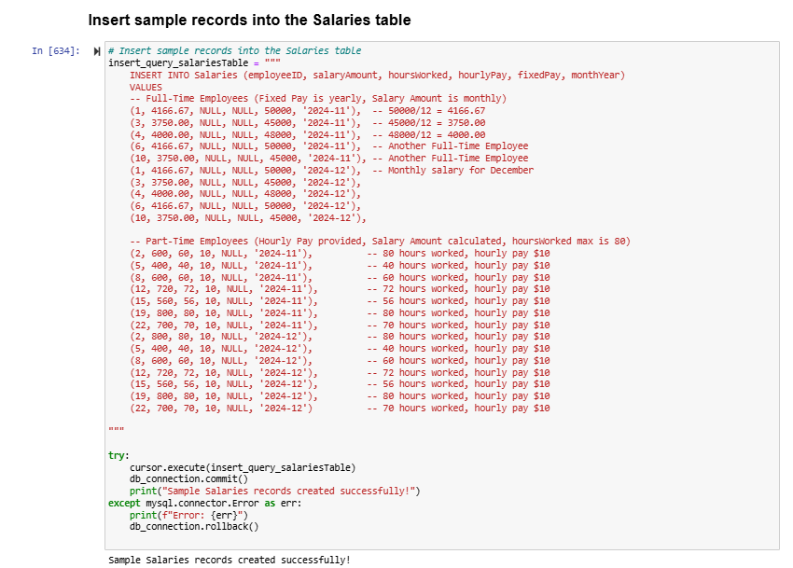
  - Vendor table data insertion
Sql statement inserts data into tables
SQL Statement –
"""
INSERT INTO Vendor (firstName, middleName, lastName, phoneNum, emailID, aptNum, streetName, city, state, pincode, category)
VALUES
('Alice', NULL, 'Supplier', '1234567890', 'alice.supplier@example.com', '12A', 'Supply Street', 'Denton', 'Texas', 76201, 'Food'),
('Bob', NULL, 'Caterer', '1234567891', 'bob.caterer@example.com', '34B', 'Vendor Lane', 'Frisco', 'Texas', 75033, 'Beverage'),
('Charlie', 'D', 'Wholesaler', '1234567892', 'charlie.wholesaler@example.com', '56C', 'Market Road', 'Aubrey', 'Texas', 76227, 'Utensils'),
('Daisy', 'E', 'Distributor', '1234567893', 'daisy.distributor@example.com', '78D', 'Trade Blvd', 'Plano', 'Texas', 75023, 'Supplies'),
('Ethan', NULL, 'Trader', '1234567894', 'ethan.trader@example.com', '90E', 'Commerce Avenue', 'Dallas', 'Texas', 75201, 'Food'),
('Fiona', 'F', 'Supplier', '1234567895', 'fiona.supplier@example.com', '11F', 'Main Street', 'Denton', 'Texas', 76202, 'Beverage'),
('George', NULL, 'Wholesaler', '1234567896', 'george.wholesaler@example.com', '22G', 'Central Road', 'Frisco', 'Texas', 75034, 'Utensils'),
('Hannah', NULL, 'Caterer', '1234567897', 'hannah.caterer@example.com', '33H', 'Event Street', 'Aubrey', 'Texas', 76228, 'Supplies'),
('Ian', 'I', 'Distributor', '1234567898', 'ian.distributor@example.com', '44I', 'Station Lane', 'Plano', 'Texas', 75024, 'Food'),
('Julia', 'J', 'Trader', '1234567899', 'julia.trader@example.com', '55J', 'Vendor Alley', 'Dallas', 'Texas', 75202, 'Beverage'),
('Kevin', NULL, 'Supplier', '12345678910', 'kevin.supplier@example.com', '66K', 'Market Boulevard', 'Denton', 'Texas', 76203, 'Utensils'),
('Laura', 'L', 'Caterer', '12345678911', 'laura.caterer@example.com', '77L', 'Trade Street', 'Frisco', 'Texas', 75035, 'Supplies'),
('Michael', NULL, 'Wholesaler', '12345678912', 'michael.wholesaler@example.com', '88M', 'Event Avenue', 'Aubrey', 'Texas', 76229, 'Food'),
('Nina', NULL, 'Distributor', '12345678913', 'nina.distributor@example.com', '99N', 'Commerce Street', 'Plano', 'Texas', 75025, 'Beverage'),
('Oliver', 'O', 'Trader', '12345678914', 'oliver.trader@example.com', '10O', 'Supply Road', 'Dallas', 'Texas', 75203, 'Utensils'),
('Paul', NULL, 'Supplier', '12345678915', 'paul.supplier@example.com', '21P', 'Vendor Lane', 'Denton', 'Texas', 76204, 'Supplies'),
('Quinn', 'Q', 'Caterer', '12345678916', 'quinn.caterer@example.com', '32Q', 'Market Street', 'Frisco', 'Texas', 75036, 'Food'),
('Rachel', NULL, 'Wholesaler', '12345678917', 'rachel.wholesaler@example.com', '43R', 'Event Boulevard', 'Aubrey', 'Texas', 76230, 'Beverage'),
('Steven', 'S', 'Distributor', '12345678918', 'steven.distributor@example.com', '54S', 'Trade Alley', 'Plano', 'Texas', 75026, 'Utensils'),
('Tina', NULL, 'Trader', '12345678919', 'tina.trader@example.com', '65T', 'Commerce Way', 'Dallas', 'Texas', 75204, 'Supplies'),
('Uma', 'U', 'Supplier', '12345678920', 'uma.supplier@example.com', '76U', 'Vendor Road', 'Denton', 'Texas', 76205, 'Food'),
('Victor', NULL, 'Caterer', '12345678921', 'victor.caterer@example.com', '87V', 'Market Lane', 'Frisco', 'Texas', 75037, 'Beverage'),
('Wendy', NULL, 'Wholesaler', '12345678922', 'wendy.wholesaler@example.com', '98W', 'Event Street', 'Aubrey', 'Texas', 76231, 'Utensils'),
('Xander', 'X', 'Distributor', '12345678923', 'xander.distributor@example.com', '10X', 'Supply Avenue', 'Plano', 'Texas', 75027, 'Supplies'),
('Yara', NULL, 'Trader', '12345678924', 'yara.trader@example.com', '20Y', 'Commerce Street', 'Dallas', 'Texas', 75205, 'Food'),
('Zane', 'Z', 'Supplier', '12345678925', 'zane.supplier@example.com', '30Z', 'Market Boulevard', 'Denton', 'Texas', 76206, 'Beverage'),
('Adam', 'A', 'Caterer', '12345678926', 'adam.caterer@example.com', '40A', 'Event Lane', 'Frisco', 'Texas', 75038, 'Utensils'),
('Bella', 'B', 'Wholesaler', '12345678927', 'bella.wholesaler@example.com', '50B', 'Vendor Avenue', 'Aubrey', 'Texas', 76232, 'Supplies'),
('Caleb', 'C', 'Distributor', '12345678928', 'caleb.distributor@example.com', '60C', 'Trade Boulevard', 'Plano', 'Texas', 75028, 'Food'),
('Diana', NULL, 'Trader', '12345678929', 'diana.trader@example.com', '70D', 'Market Street', 'Dallas', 'Texas', 75206, 'Beverage')
"""
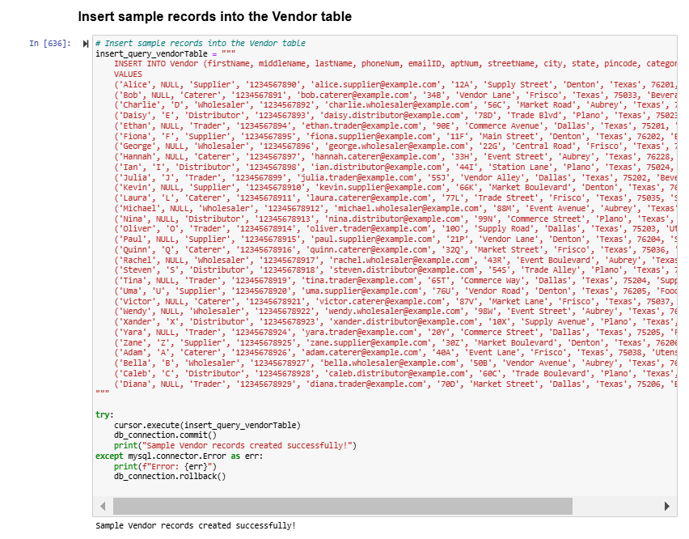
  - Inventory table data insertion
Sql statement inserts data into tables
SQL Statement –
"""
INSERT INTO Inventory (itemName, itemCategory, quantity, vendorID, eventID)
VALUES
('Napkins', 'Supplies', 1000, 1, 1),
('Water Bottles', 'Beverage', 500, 2, 2),
('Plates', 'Utensils', 300, 3, 3),
('Spoons', 'Utensils', 200, 3, NULL),
('Tablecloths', 'Supplies', 50, 1, 4),
('Cups', 'Beverage', 600, 2, 5),
('Bowls', 'Utensils', 150, 3, 6),
('Serving Trays', 'Supplies', 30, 4, 7),
('Juice Bottles', 'Beverage', 400, 5, 8),
('Forks', 'Utensils', 250, 3, NULL),
('Chairs', 'Supplies', 100, 6, 9),
('Soft Drinks', 'Beverage', 350, 7, 10),
('Glasses', 'Utensils', 200, 3, 11),
('Ice Buckets', 'Supplies', 40, 8, 12),
('Wine Bottles', 'Beverage', 150, 9, 13),
('Dish Towels', 'Supplies', 80, 1, 14),
('Knives', 'Utensils', 100, 3, NULL),
('Coffee Cups', 'Beverage', 300, 2, 15),
('Serving Bowls', 'Utensils', 100, 3, 16),
('Cutlery Set', 'Supplies', 50, 10, NULL),
('Disposable Cups', 'Beverage', 400, 11, 17),
('Plastic Plates', 'Supplies', 200, 3, 18),
('Silverware', 'Utensils', 80, 12, 19),
('Beer Cans', 'Beverage', 250, 2, 20),
('Decorative Lights', 'Supplies', 15, 13, NULL),
('Cocktail Glasses', 'Utensils', 120, 3, 21),
('Appetizer Plates', 'Supplies', 60, 14, 22),
('Table Mats', 'Supplies', 200, 1, NULL),
('Sparkling Water', 'Beverage', 300, 5, 23),
('Bar Tools', 'Supplies', 20, 15, 24)
"""
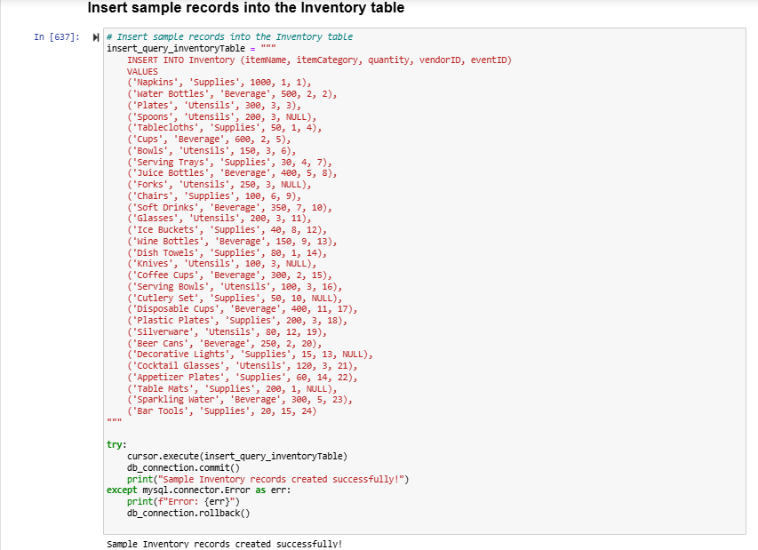
  - EmployeeEventAssignments data insertion
Sql statement inserts data into tables
SQL Statement –
"""
INSERT INTO EmployeeEventAssignments (employeeID, eventID, taskDescription)
VALUES
(2, 1, 'Set up venue'),
(3, 1, 'Coordinate logistics'),
(4, 2, 'Serve food'),
(5, 3, 'Arrange supplies'),
(6, 4, 'Manage guest seating'),
(2, 5, 'Assist with decorations'),
(3, 5, 'Serve food'),
(8, 6, 'Set up sound system'),
(12, 7, 'Manage event flow'),
(15, 8, 'Clean up post-event'),
(19, 9, 'Distribute beverages'),
(22, 10, 'Help with setup'),
(25, 11, 'Handle registration'),
(27, 12, 'Supervise activities'),
(11, 13, 'Coordinate security'),
(2, 14, 'Help with decorations'),
(5, 15, 'Manage guest list'),
(8, 16, 'Arrange seating'),
(12, 17, 'Support logistics team'),
(15, 18, 'Oversee food delivery'),
(19, 19, 'Prepare venue for event'),
(22, 20, 'Monitor event operations'),
(25, 21, 'Coordinate with vendors'),
(27, 22, 'Supervise part-time staff'),
(11, 23, 'Set up lighting'),
(2, 24, 'Handle guest complaints'),
(3, 25, 'Help with packing'),
(4, 26, 'Assist in inventory'),
(5, 27, 'Supervise entrance'),
(6, 28, 'Manage technical equipment')
"""
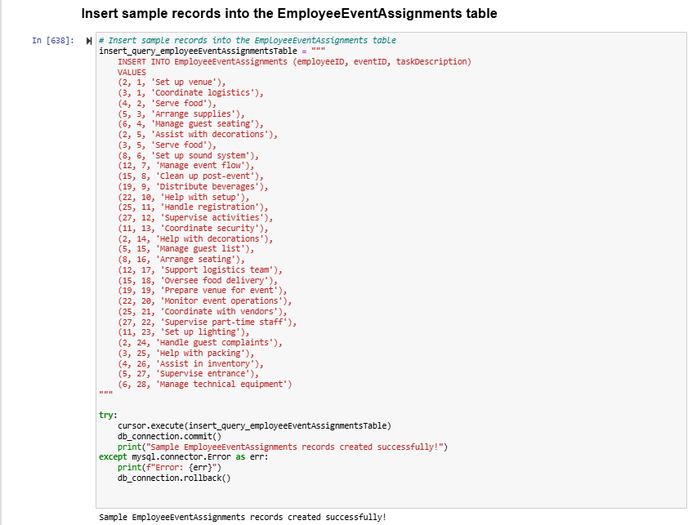

Data Retrieval and Simple Reports
    - This query calculates the total salary paid to employees in December 2024, grouped by their employment type (e.g., Full-Time, Part-Time).
SQL Statement =
"""
SELECT
e.employmentType,
SUM(s.salaryAmount) AS totalSalaryPaid
FROM
Employee e
JOIN
Salaries s ON e.employeeID = s.employeeID
WHERE
s.monthYear = '2024-12'
GROUP BY
e.employmentType;
"""

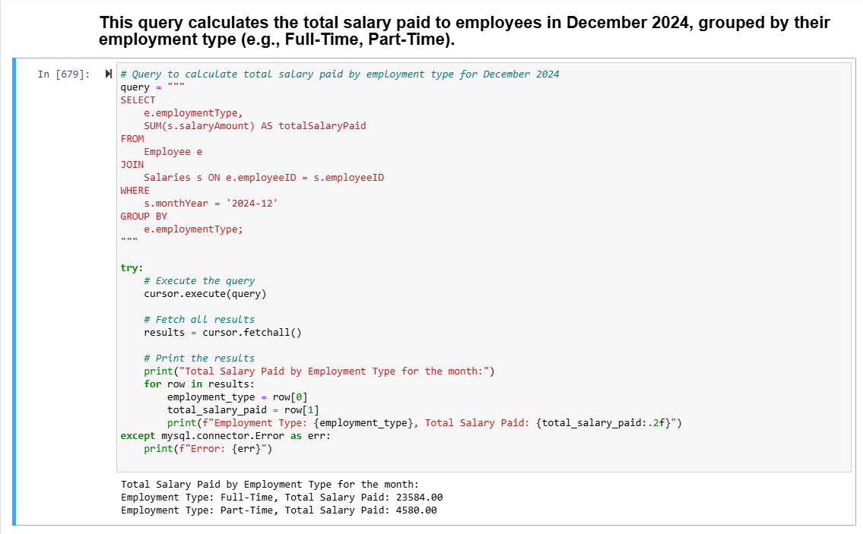

    - This query counts the number of events hosted at each location and orders the results by the total number of events in descending order (most events first).

SQL Statement =
"""
SELECT
l.locationName,
COUNT(e.eventID) AS eventCount
FROM
Location l
JOIN
Events e ON l.locationID = e.locationID
GROUP BY
l.locationName
ORDER BY
eventCount DESC;
"""

"""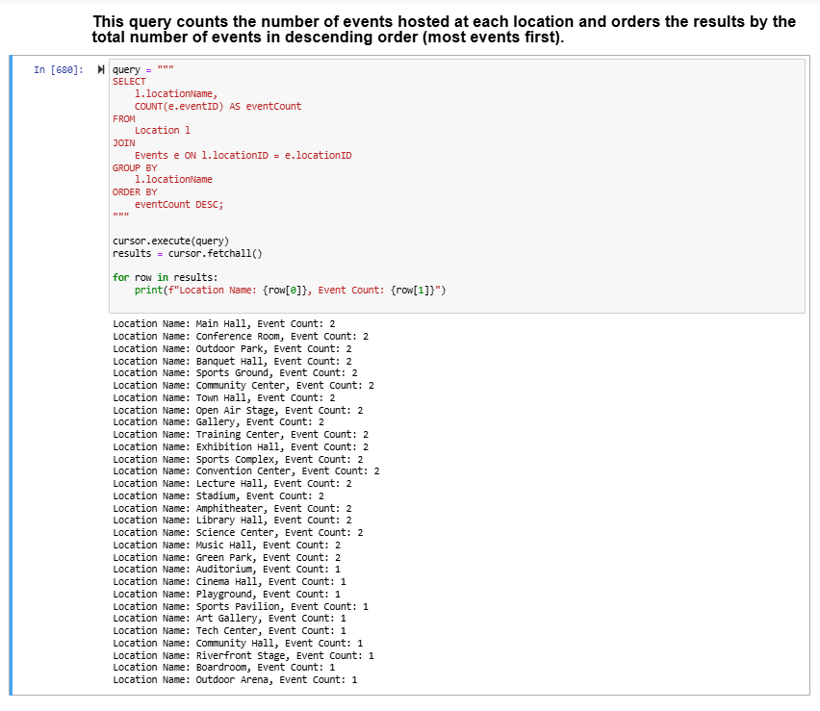

    - This query identifies the top 5 employees who have the highest number of event assignments and lists their first name, last name, and total number of assignments.

SQL Statement =
"""
SELECT
e.firstName,
e.lastName,
COUNT(eea.assignmentID) AS totalAssignments
FROM
Employee e
JOIN
EmployeeEventAssignments eea ON e.employeeID = eea.employeeID
GROUP BY
e.employeeID
ORDER BY
totalAssignments DESC
LIMIT 5;
"""
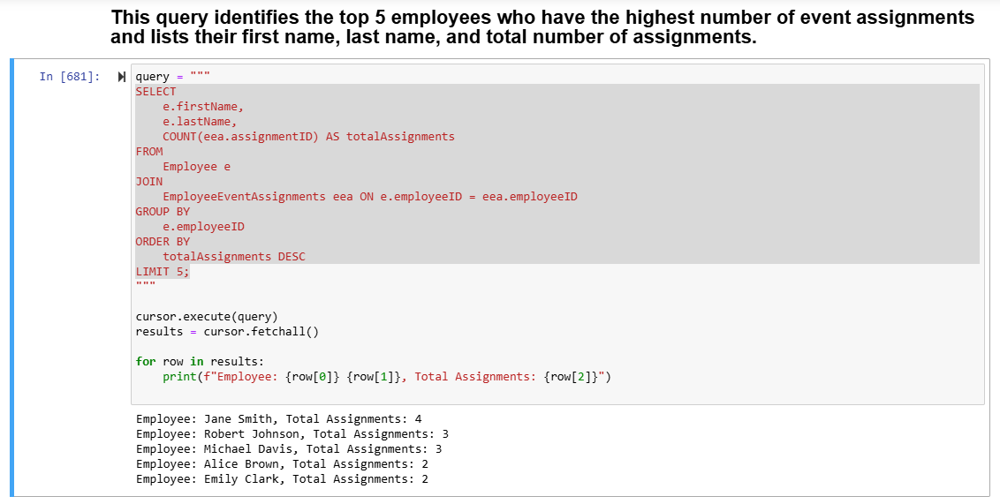

    - This query retrieves the top 5 employees with the highest number of event assignments, along with their first name, last name, total assignments, and a list of the names of the events they worked on.

SQL Statement =
"""
SELECT
e.firstName,
e.lastName,
COUNT(eea.assignmentID) AS totalAssignments,
GROUP_CONCAT(ev.eventName SEPARATOR ', ') AS eventNames
FROM
Employee e
JOIN
EmployeeEventAssignments eea ON e.employeeID = eea.employeeID
JOIN
Events ev ON eea.eventID = ev.eventID
GROUP BY
e.employeeID
ORDER BY
totalAssignments DESC
LIMIT 5;
"""
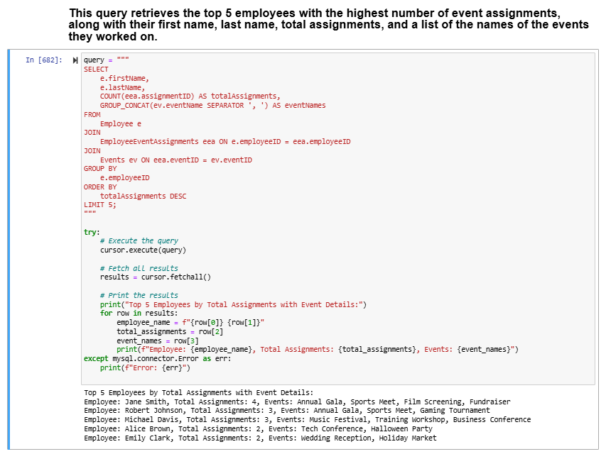

    - This query retrieves information about the total number of coupons issued to each employee and how many of those coupons have been redeemed.

SQL Statement =
"""
SELECT
e.firstName,
e.lastName,
COUNT(c.couponID) AS totalCouponsIssued,
SUM(CASE WHEN c.redemptionStatus = 'Redeemed' THEN 1 ELSE 0 END) AS totalCouponsRedeemed
FROM
Employee e
JOIN
Coupons c ON e.employeeID = c.employeeID
GROUP BY
e.employeeID;
"""

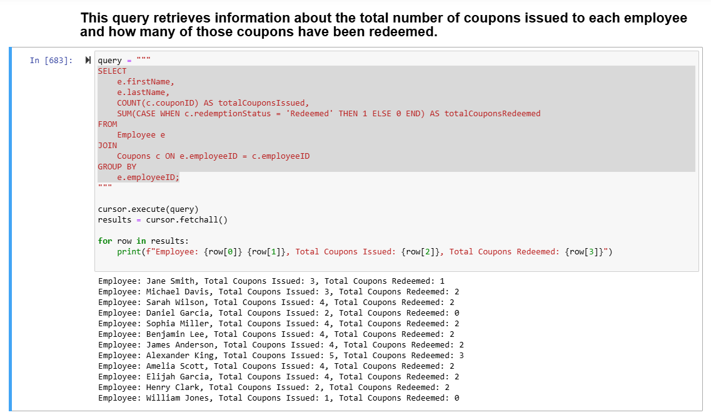

    - This query retrieves the first name and last name of employees who are assigned to events taking place at the location with the maximum capacity.

SQL Statement =
"""
SELECT firstName, lastName
FROM Employee
WHERE employeeID IN (
SELECT employeeID
FROM EmployeeEventAssignments
WHERE eventID IN (
SELECT eventID
FROM Events
WHERE locationID = (
SELECT locationID
FROM Location
WHERE capacity = (SELECT MAX(capacity) FROM Location)
)
)
);
"""
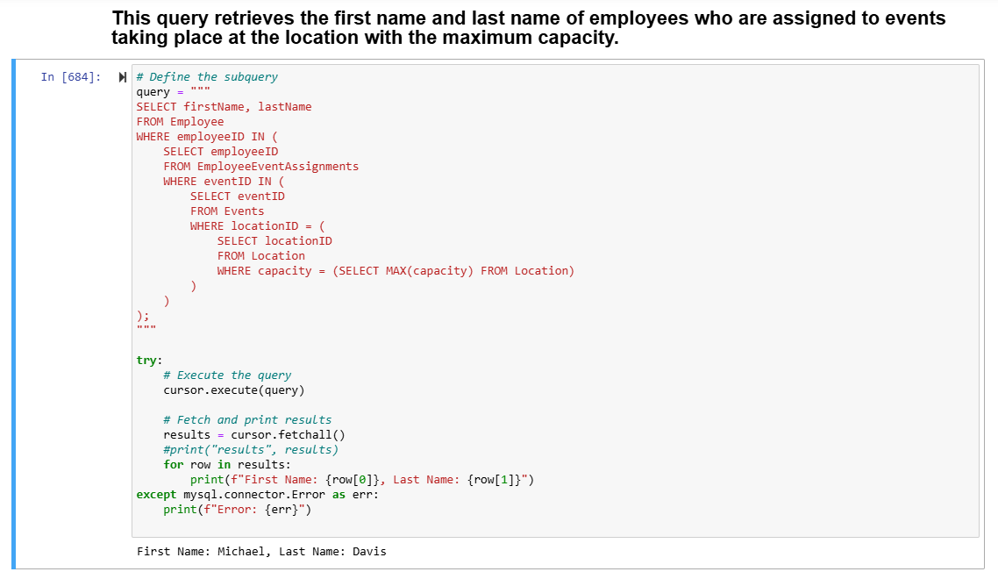

    - This query retrieves the first name and last name of employees who are assigned to events taking place at the location with the maximum capacity.

SQL Statement =
"""
SELECT firstName, lastName
FROM Employee
WHERE employeeID IN (
SELECT employeeID
FROM EmployeeEventAssignments
WHERE eventID IN (
SELECT eventID
FROM Events
WHERE locationID IN (
SELECT locationID
FROM Location
WHERE city = 'frisco'
)
)
);
"""

